**UNIT I NETWORK LAYER SECURITY &TRANSPORT LAYER SECURITY**

IPSec Protocol - IP Authentication Header - IP ESP - Key Management Protocol for IPSec . Transport layer Security: SSL protocol, Cryptographic Computations – TLS Protocol.

**UNIT I**

**NETWORK LAYER SECURITY &TRANSPORT LAYER SECURITY**

**IPSec Protocol**

IPsec is designed to protect communication in a secure manner by using TCP/IP. The IPsec protocol is a set of security extensions developed by the IETF and it provides privacy and authentication services at the IP layer by using modern cryptography.

To protect the contents of an IP datagram, the data is transformed using encryption algorithms.

There are two main transformation types that form the basics of IPsec:

The Authentication Header (AH) and

The Encapsulating Security Payload (ESP).

Both AH and ESP are two protocols that provide **connectionless integrity, data origin authentication, confidentiality and an anti-replay service**. These protocols may be applied alone or in combination to provide a desired set of security services for the IP layer. They are configured in a data structure called a Security Association (SA).

**The** basic components of the **IPsec security architecture** are explained in terms of the following **functionalities:**

* Security Protocols for AH and ESP
* Security Associations for policy management and traffic processing
* Manual and automatic key management for the Internet Key Exchange (IKE), the Oakley key determination protocol and ISAKMP.
* Algorithms for authentication and encryption

**INTERNET SECURITY**

**The set of security services provided at the IP layer**

access control,

connection-less integrity

data origin authentication,

protection against replays and confidentiality.

The modularity which is designed to be algorithm independent permits selection of different sets of algorithms without affecting the other parts of the implementation.

A standard set of default algorithms is specified to facilitate interoperability in the global Internet.

The use of these algorithms in conjunction with IPsec traffic protection and key management protocols is intended to permit system and application developers :

To deploy high-quality,

Internet layer

cryptographic security technology.

Thus, the suite of IPsec protocols and associated default algorithms is designed to provide high-quality security for Internet traffic.

**An IPsec implementation operates in a host** or a security gateway environment, **afford-ing protection to IP traffic**.

* The protection offered is based on requirements defined by a Security Policy Database (SPD) established and maintained by a user or system administrator.
* IPsec provides security services at the IP layer by enabling a system to select the required security protocols, determine the algorithms to use for the services,
* and put in place any cryptographic keys required to provide the requested service.

**IPsec can be used to protect** one or more paths between a pair of hosts, between a pair of security gateways (routers or firewalls) or between a security gateway and a host.

**IPsec Protocol Documents**

This section will discuss the protocols and standards which apply to IPsec.

**The set of IPsec protocols** is divided into **seven groups** as illustrated in Figure 7.1.

In November 1998, the Network Working Group of the IETF published RFC 2411 for IP Security Document Roadmap. This document is intended to provide guidelines for the development of collateral specifications describing the use of new encryption and authentication algorithms used with the AH protocol as well as the ESP protocol. Both these protocols are part of the IPsec architecture.

The seven-group documents describing the set of IPsec protocols are explained in the following:

* ***Architecture*:** The main architecture document covers the general concepts, securityrequirements, definitions and mechanisms defining IPsec technology.
* ***ESP***: This document covers the packet format and general issues related to the useof the ESP for packet encryption and optional authentication. This protocol document also contains default values if appropriate, and dictates some of the values in the Domain of Interpretation (DOI).
* ***AH***: This document covers the packet format and general issue related to the use ofAH for packet authentication. This document also contains default values such as the default padding contents, and dictates some of the values in the DOI document.
* ***Encryption algorithm***: This is a set of documents that describe how various encryptionalgorithms are used for ESP.

Specifically:

– Specification of the key sizes and strengths for each algorithm.

– Any available estimates on performance of each algorithm.

– General information on how this encryption algorithm is to be used in ESP.

Features of this encryption algorithm to be used by ESP, including encryption and/or authentication.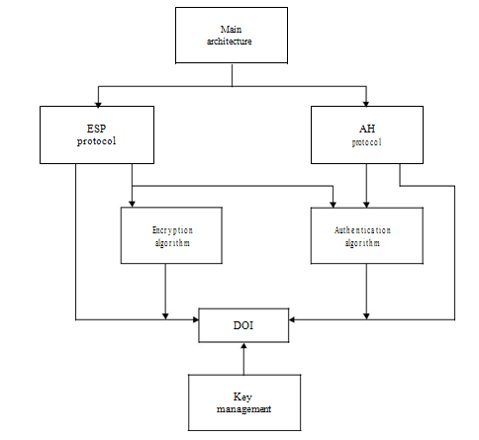

**Figure -**Document overview that defines IPsec.

When these encryption algorithms are used for ESP, the DOI document has to indicate certain values, such as an encryption algorithm identifier, so these documents provide input to the DOI.

* ***Authentication algorithm***: This is a set of documents that describe how various authen-tication algorithms are used for AH and for the authentication option of ESP. Specifically:

– Specification of operating parameters such as number of rounds, and input or output block format.

– Implicit and explicit padding requirements of this algorithm.

– Identification of optional parameters/methods of operation.

– Defaults and mandatory ranges of the algorithm.

– Authentication data comparison criteria for the algorithm.

* ***Key management***: This is a set of documents that describe key management schemes.These documents also provide certain values for the DOI. Currently the key manage-ment represents the Oakley, ISAKMP and Resolution protocols.
* ***DOI***: This document contains values needed for the other documents to relate eachother. These include identifiers for approved encryption and authentication algorithms, as well as operational parameters such as key lifetime.

**II-IP Authentication Header**

* The IP AH is used to provide data integrity and authentication for IP packets.
* It also provides protection against replays.
* The AH provides authentication for the IP header, as well as for upper-level protocol (TCP, UDP) data.

But some IP header fields may change in transit and the sender may not be able to predict the value of these fields when the packet arrives at the receiver.

The AH can be used in conjunction with ESP or with the use of tunnel mode.

Security services can be provided between a pair of hosts, between a pair of security gateway or between a security gateway and a host.

**The ESP provides a confidentiality service**.

The **primary difference** between the authentication provided by ESP and AH is the **extent of the coverage**.

ESP does not protect any IP header fields unless these fields are encapsulated by ESP (tunnel mode). The current key management options required for both AH and ESP are manual keying and automated keying via IKE. Authentication is based on the use of an MAC or the Integrity Check Value (ICV) computation so that two hosts must share a secret key.

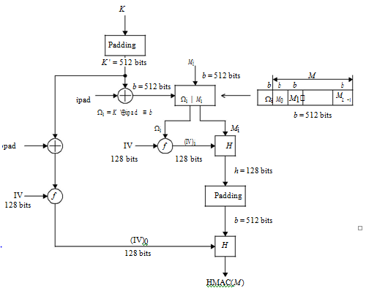

**AH Format**

The IPsec AH format is shown in Figure.

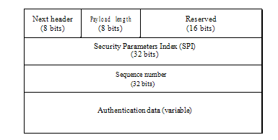

**Figure 7.4** IPsec AH format.

The following six fields comprise the AH format:

• ***Next header*** *(8 bits)*: This field identifies the type of the next payload after the AH.The value of this field is chosen from the set of IP numbers defined in the Internet Assigned Number Authority (IANA).

• ***Payload length*** *(8 bits)*: This field specifies the length of the AH in 32-bit words,minus 2. The default length of the authentication data field is 96 bits, or three 32-bit words. With a three-word fixed header, there are a total of six words in the header, and the payload length field has a value of 4.

• ***Reserved (1****6 bits)*: This field is reserved for future use. It must be set to ‘zero’.

* ***SPI (32 bits)*:** This field uniquely identifies the SA for this datagram, in combinationwith the destination IP address and security protocol (AH).

The set of SPI values in the range 1 – 255 is reserved by the IANA for future use. The SPI value of zero (0) is reserved for local, implementation-specific use. A key management implementation may use the zero SPI value to mean ‘No Security Association Exists’ during the period when the IPsec implementation has requested that its key management entity establish a new SA, but the SA has not yet been established.

* ***Sequence number (32 bits****)*: This field contains the monotonically increasing countervalue which provides an anti-replay function. Even if the sender always transmits this field, the receiver need not act on it, i.e. processing of the sequence number field is at the discretion of the receiver. The sender’s counter and the receiver’s counter are initialised to zero when an SA is established. The first packet sent using a given SA will have a sequence number of 1. The sender increments the sequence number for this SA and inserts the new value into the sequence number field.

If anti-replay is enabled, the sender checks to ensure that the counter has not cycled before inserting the new value in the sequence number field. If the counter has cycled, the sender will set up a new SA and key. If the anti-replay is disabled, the sender does not need to monitor or reset the counter. However, the sender still increments the counter and when it reaches the maximum value, the counter rolls over to zero.

* ***Authentication data (variable****)*: This field is a variable-length field that contains theIntegrity Check Value (ICV) or MAC for this packet. This field must be an integral multiple of 32-bit words. It may include explicit padding. This padding is included to ensure that the length of AH is an integral multiple of 32 bits (IPv4) or 64 bits (IPv6).

**AH Location**

Either AH or ESP is employed in two ways: transport mode or tunnel mode. The transport mode is applicable only to host implementations and provides protection for upper-layer protocols. In the transport mode, AH is inserted after the IP header and before an upper-layer protocol (TCP, UDP or ICMP), or before any other IPsec header that may have already been inserted.

In the IPv4 context, AH is placed after the original IP header and before the upper-layer protocol TCP or UDP. Note that an ICMP message may be sent using either the transport mode or the tunnel mode. Authentication covers the entire packet, excluding mutable fields in the IPv4 header that are set to zero for MAC computation. The positioning of AH transport mode for an IPv4 packet is illustrated in Figure 7.5(a).

In the IPv6 context, AH should appear after hop-to-hop, routing and fragmentation extension headers. The destination options extension header(s) could appear either before or after AH, depending on the semantics desired. Authentication again covers the entire packet, excluding mutable fields that are set to zero for MAC computation. The positioning of AH transport mode for an IPv6 packet is illustrated in Figure 7.5(b).

Tunnel mode AH can be employed in either hosts or security gateways. When AH is implemented in a security gateway to protect transit traffic, tunnel mode must be used. In tunnel mode, the *inner* IP header carries the ultimate source and destination addresses, while an *outer* IP header may contain different IP addresses (i.e. addresses of firewalls or other security gateways).

In tunnel mode, AH protects the entire inner IP packet, including the entire inner IP header. The position of AH in tunnel mode, relative to the outer IP header, is the same as for AH in transport mode.

Figure 7.5(c) illustrates AH tunnel mode positioning for typical IPv4 and IPv6 packets.

**IP ESP**

The ESP header is designed to provide security services in IPv4 and IPv6. ESP can be applied alone, in combination with the IP AH or through the use of tunnel mode. Security services are provided between a pair of hosts, between a pair of security gateways or between a security gateway and a host.

The ESP header is inserted after the IP header and before the upper-layer protocol header (transport mode) or before an encapsulated IP header (tunnel mode).

ESP is used to provide **confidentiality (encryption), data authentication, integrity and anti-replay service, and limited traffic flow confidentiality**.

Confidentiality could be selec-ted independent of all other services. However, use of confidentiality without integrity/ authentication may subject traffic to certain forms of active attacks that undermine the con-fidentiality service. Data authentication and integrity are joint services offered as an option with confidentiality. The anti-replay service is chosen only if data origin authentication is selected and the service is effective only if the receiver checks the sequence number. The current key management options required for both AH and ESP are manual keying and automated keying via IKE.

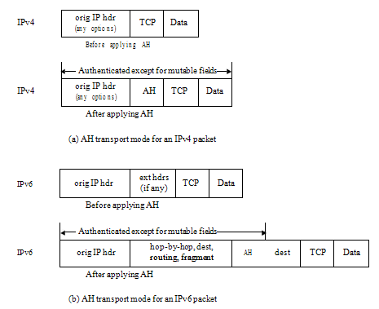

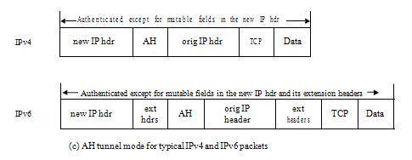

**Figure 7.5** Transport mode and tunnel mode for AH authentication.

**ESP Packet Format**

Figure 7.6 shows the format of an ESP packet and the fields in the header format are defined in the following.

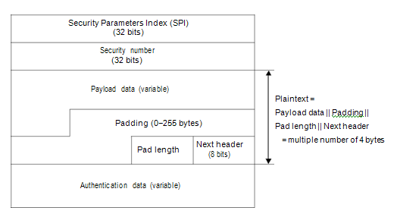

**Figure** IPsec ESP format.

• ***SPI (32 bits****)*: The SPI is an arbitrary 32-bit value that uniquely identifies an SA forthis datagram. The set of SPI values in the range 1 – 255 is reserved by the IANA for future use. The SPI field in the ESP packet format is mandatory and always present.

* ***Sequence number*** *(32 bits)*: This field contains a monotonically increasing countervalue. This provides an anti-replay function. It is mandatory and is always present even if the receiver does not elect to enable the anti-replay service for a specific SA. If anti-replay is enabled, the transmitted sequence number must not be allowed to cycle. Thus, the sender’s counter and the receiver’s counter must be reset prior to the transmission of the 232 nd packet on an SA.
* ***Payload data (variable****)*: This variable-length field contains data described by the nextheader field. The field is an integral number of bytes in length. If the algorithm requires an initialisation vector (IV) to encrypt payload, then this data may be carried explicitly in the payload field. Any encryption algorithm that requires such IP data must indicate the length, structure and location of this data by specifying how the algorithm is used with ESP. For some IP-based modes of operation, the receiver treats the IP as the start of the ciphertext, feeding it into the algorithm directly.
* ***Padding* :** This field for encryption requires several factors:

– If an encryption algorithm requires the plaintext to be a multiple number of bytes, the padding field is used to fill the plaintext to the size required by the algorithm. The plaintext consists of the payload data, pad length and next header field, as well as the padding (see Figure 7.6)

– Padding is also required to ensure that the ciphertext terminates on a32-bit boundary. Specifically, the pad length and next header fields must be right aligned within a 32-bit word to ensure that the authentication data field is aligned on a 32-bit boundary.

The sender may add 0 – 255 bytes of padding. Inclusion of the

padding field in an ESP packet is optional, but all implementations

must support the generation and consumption of padding. For the purpose of ensuring that either the bits to be encrypted are a multiple of the algorithm’s block size or the authentication data is aligned on a 32-bit boundary, the padding is applied to the payload data exclusive of the IV, the pad length and next header fields.

The padding bytes are initialized with a series of integer values such that the first padding byte appended to the plaintext is numbered 1, with subsequent padding bytes following a monotonically increasing sequence: 1, 2, 3, *. . .*. When this padding scheme is employed, the receiver should inspect the padding field. Any encryption algorithm requiring padding must define the padding contents, while any required receiver must process these padding bytes in specifying how the algorithm is used with ESP. In such circumstances, the encryption algorithm and mode selected will determine the content of the padding field. Subsequently, a receiver must inspect the padding field and inform senders of how the receiver will handle the padding field.

* ***Pad length***: This field indicates the number of pad bytes immediately preceding it.The range of valid values is 0 – 255, where a value of 0 indicates that no padding bytes are present. This field is mandatory.

• ***Next header*** *(8 bits)*: This field identifies the type of data contained in the payloaddata field, i.e. an extension header in IPv6 or an upper-layer protocol identifier. The value of this field is chosen from the set of IP numbers defined by the IANA. The next header field is mandatory.

* ***Authentication data (variable)***: This is a variable-length field containing an ICV com-puted over the ESP packet minus the authentication data. The length of this field is specified by the authentication function selected. The field is optional and is included only if the authentication service has been selected for the SA in question. The authen-tication algorithm must specify the length of the ICV and the comparison rules and processing steps for validation.

**ESP Header Location**

Like AH, ESP is also employed in the two transport or tunnel modes.

The transport mode is applicable only to host implementations and provides protection for upper protocols, but not the IP header.

In the transport mode, ESP is inserted after the IP header and before an upper-layer protocol (TCP, UDP or ICMP), or before any other IPsec headers that have already been inserted.

In the IPv4 context, ESP is placed after the IP header, but before the upper-layer protocol. Note that an ICMP message may be sent using either the transport mode or the tunnel mode.

Figure 7.7(a) illustrates ESP transport mode positioning for a typical IPv4 packet, on a *before and after* basis.

The ESP trailer encompasses any padding, plus the pad length, and next header fields.

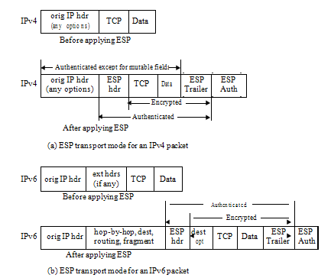

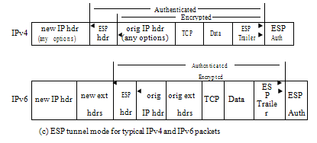

**Figure** Transport mode and tunnel mode for ESP authentication.

In the IPv6 context, the ESP appears after hop-by-hop, routing and fragmentation extension headers.

The destination options extension header(s) could appear either before or after the ESP header depending on the semantics desired.

However, since ESP protects only fields after the ESP header, it is generally desirable to place the destination options header(s) after the ESP header.

Figure 7.7(b) illustrates ESP transport mode positioning for a typical IPv6 packet.

Tunnel mode ESP can be employed in either hosts or security gateways. When ESP is implemented in a security gateway to protect subscriber transit traffic, tunnel mode must be used.

In tunnel mode, the *inner* IP header carries the ultimate source and destination addresses, while an *outer* IP header may contain different IP addresses such as addresses of security gateways.

In tunnel mode, ESP protects the entire inner IP packet, including the entire inner IP header.

The position of ESP in tunnel mode, relative to the outer IP header, is the same as for ESP in transport mode.

Figure 7.7(c) illustrates ESP tunnel mode positioning for typical IPv4 and IPv6 packets.

**Encryption and Authentication Algorithms**

ESP is applied to an outbound packet associated with an SA that calls for ESP process-ing. The encryption algorithm employed is specified by the SA, as is the authentication algorithm.

*Encryption*

ESP is designed for use with symmetric algorithms like a triple DES in CBC mode. How-ever, a number of other algorithms have been assigned identifiers in the DOI document.

**These algorithms for encryption are: RC5, IDEA, CAST and Blowfish.**

For encryption to be applied, the sender encapsulates the ESP payload field, adds any necessary padding, and encrypts the result (i.e. payload data, padding, pad length and next header).

The sender encrypts the fields (payload data, padding, pad length and next header) using the key, encryption algorithm, algorithm mode indicated by the SA and an IV (cryptographic synchronisation data).

If the algorithm to be encrypted requires an IV, then this data is carried explicitly in the payload field.

The payload data field is an integral number of bytes in length.

Since ESP provides padding for the plaintext, encryption algorithms employed by ESP exhibit either block or stream mode characteristics.

The encryption is performed before the authentication and does not encompass the authentication data field.

The order of this processing facilitates rapid detection and rejec-tion of replayed or bogus packets by the receiver, prior to decrypting the packet.

Therefore, it will **reduce the impact of service attacks.**

At the receiver, parallel processing of packets is possible because decryption can take place in parallel with authentication.

Since the authentication data is not protected by encryption, a keyed authentication algorithm must be employed to compute the ICV.

Referring to Figure 7.8, the 3DES – CBC mode requires an IV that is the same size as the block size.

The IV is XORed with the first plaintext block before it is encrypted. For successive blocks, the previous ciphertext block is XORed with the current plaintext before it is encrypted. Triple DES, known as DES – EDE3, processes each block three times, each time with a different key. Therefore, the triple DES algorithm has 48 rounds. In DES – EDE3-CBC, an IV is XORed with the first 64-bit plaintext block (P1).

Some cipher algorithms allow for a variable-sized key (RC5), while others only allow a specific key size (DES, IDEA).

*Decryption*

The receiver decrypts the ESP payload data, padding, pad length and next header using the key, encryption algorithm, algorithm mode and IV data. If explicit IV data is indicated, it

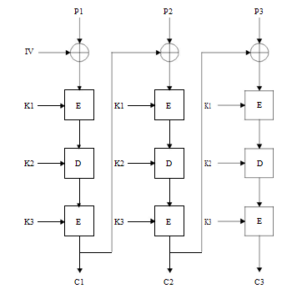

**Figure 7.8** DES – EDE3 – CBC algorithm.

is taken from the payload field and input to the decryption algorithm. If implicit IV data is indicated, a local version of the IV is constructed and input to the decryption algorithm.

The exact steps for reconstructing the original datagram depend on the mode (transport or tunnel) and are described in the Security Architecture document.

The receiver processes any padding as given in the encryption algorithm specification.

* For transport mode, the receiver reconstructs the original IP datagram from the original IP header plus the original upper-layer protocol information in the ESP payload field.
* For tunnel mode, the receiver reconstructs the tunnel IP header plus the entire IP datagram in the ESP payload field.

If authentication has been computed, verification and decryption are performed serially or in parallel. If performed serially, then ICV or MAC verification should be performed first.

If performed in parallel, verification must be completed before the decrypted packet is passed on for further processing.

This order of processing facilitates rapid detection and rejection of replayed or bogus packets by the receiver.

***Authentication***

The authentication algorithm employed for the ICV computation is specified by the SA.

For communication between two points, suitable authentication algorithms include Keyed Message Authentication Codes (MACs) based on symmetric encryption algorithms (i.e. DES) or on one-way hash function (i.e. MD5 or SHA-1).

For multicast communication, one-way hash algorithms combined with asymmetric signature algorithms are appropriate.

If authentication is selected for the SA, the sender computes the ICV over the ESP packet minus the authentication data.

As stated previously, the fields of payload data, padding, pad length and next header are all in ciphertext form because encryption is performed prior to authentication.

Thus, the SPI, sequence numbers and these four fields are all encompassed by the ICV computation.

*ICV*

Once the SA selects the authentication algorithm, the sender computes the ICV over the ESP packet minus the authentication data. The ICV is an MAC or a truncated value of a code produced by an MAC algorithm. As with AH, ESP supports the use of an MAC with a default length of 96 bits. The current specification for use of the

HMAC computation must support:

HMAC – MD5 – 96

HMAC – SHA-1 – 96

Management Protocol for IPSec

**Key Management Protocol for IPsec**

The key management mechanism of IPsec involves the determination and distribution of a secret key. Key establishment is at the heart of data protection that relies on cryptography. A secure key distribution for the Internet is an essential part of packet protection.

Prior to establishing a secure session, the communicating parties need to negotiate the terms that are defined in the SA. An automated protocol is needed in order to establish the SAs for making the process feasible on the Internet. This automated process is the IKE. IKE combines ISAKMP with the Oakley key exchange.

We begin our discussion with an overview of Oakley and then look at ISAKMP.

**OAKLEY Key Determination Protocol**

The Diffie – Hellman key exchange algorithm provides a mechanism that allows two users to agree on a shared secret key without requiring encryption.

This shared key is immedi-ately available for use in encrypting subsequent data transmission.

Oakley is not only a refinement of the Diffie – Hellman key exchange algorithm, but a method to establish an authentication key exchange.

The Oakley protocol is truly used to establish a shared key with an assigned identifier and associated authenticated identities for the two parties.

Oak-ley can be used directly over the IP protocol or over UDP protocol using a well-known port number assignment available.

It is worth to note that **Oakley uses the cookies** for **two purposes**:

* anti-clogging (denial of service) and
* key naming.

The **anti-clogging** tokens provide a form of source address identification for both parties. The construction of the cookies prevents an attacker from obtain a cookie using a real IP address and UDP port.

Creating the cookie is to produce the result of a one-way function applied to a secret value, the IP source and destination addresses, and the UDP source and destination ports.

Protection against the anti-clogging always seems to be one of the most difficult to address.

**A cookie or anti-clogging token is aimed for protecting the computing resources from** **attack without spending excessive CPU resources to determine its authenticity.**

Absolute protection against anti-clogging is impossible, but this anti-clogging token provides a technique for making it easier to handle.

Oakley employs *nonces* to ensure against replay attacks. Each nonce is a pseudorandom number which is generated by the transmitting entity. The nonce payload contains this random data used to guarantee liveness during a key exchange and protect against replay attacks. If nonces are used by a particular key exchange, the use of the nonce payload will be dictated by the key exchange. The nonces may be transmitted a part of the key exchange data.

All the Oakley message fields correspond to ISAKMP message payloads. The relevant payload fields are the SA payload, the authentication payload, the certification payload, and the exchange payload.

Oakley is the actual instantiation of ISAKMP framework for IPsec key and SA generation.

The exact mapping of Oakley message fields to ISAKMP payloads is in progress at this time.

**ISAKMP**

* ISAKMP defines a framework for SA management and cryptographic key establishment for the Internet.
* This framework consists of defined exchange, payloads and processing guidelines that occur within a given DOI.
* ISAKMP defines procedures and packet formats to establish, negotiate, modify and delete SAs.
* It also defines payloads for exchanging key generation and authentication data.

These payload formats provide a consistent framework for transferring key and authentication data which is independent of the key generation technique, encryption algorithm and authentication mechanism.

ISAKMP is intended to support the negotiation of SAs for security protocols at all layers of the network stack. By centralising the management of the SAs, ISAKMP reduces the amount of duplicated functionality within each security protocol.

**(I) ISAKMP Payloads**

ISAKMP payloads provide modular building blocks for constructing ISAKMP messages. The presence and ordering of payloads in ISAKMP is defined by and dependent upon the Exchange Type Field located in the ISAKMP Header.

**ISAKMP Header**

**The ISAKMP header fields** are fined as shown in Figure 7.9.

**Initiator Cookie (64 bits)**

This field is the cookie of entity that initiated SA establishment, SA notification, or SA deletion.

**Responder Cookie (64 bits)**

This field is the cookie of entity that is corresponded to an SA establishment request, SA notification, or SA deletion.

**Next Payload (8 bits)**

This field indicates the type of the first payload in the message.

Major Version (4 bits)

This field indicates the Major version of the ISAKMP protocol in use. Set the Major version to 1 according to ISAKMP Internet-Draft.

Minor Version (4 bits)

This field indicates the Minor version of ISAKMP protocol in use. Set the Minor version to 0 according to implementations based on the ISAKMP Internet-Draft.

Exchange Type (8 bits)

This field indicates the type of exchange being used. This dictates the message and payload orderings in the ISAKMP exchanges.

Flags (8 bits)

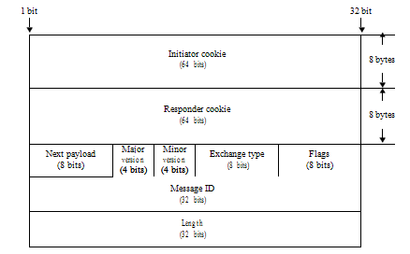

**Figure** ISAKMP header format.

This field indicates specific options that are set for the ISAKMP exchange. The Flags are specified in the Flags field beginning with the least significant bit: the encryption bit is bit 0 of the Flags field, the commit bit is bit 1, and authentication only bit is bit 2 of the Flags field. The remaining bits of the Flags field must be set to 0 prior to transmission.

– All payloads following the header are encrypted using the encryption algorithm identified in the ISAKMP SA. The encryption should begin after both parties have exchanged Key Exchange payloads.

– The commit bit is used to signal key exchange synchronization. In addition to synchronizing key exchange, the commit bit can be used to protect against loss of transmissions over unreliable networks and guard against the need for multiple retransmissions.

– Authentication only bit is intended for use with the information exchange with a notify payload and will allow the transmission of information with integrity checking, but no encryption.

|  |  |
| --- | --- |
|  |  |

Message ID (32 bits)

Message ID is used to identify protocol state during Phase 2 negotiations. This value is randomly generated by the initiator of the phase 2 negotiation. During Phase 1 negotiation, this value must be set to 0.

Length (32 bits)

Length of total message (header || payload) is 32 bits. Encryption can expand the size of an ISAKMP message.

**Generic Payload Header**

Each ISAKMP payload begins with a generic header which provides a payload chaining capability and clearly defines the boundaries of a payload.

The generic payload header fields in 32 bits are defined as follows:

Next Payload (8 bits)

This field is identifier for the payload type of the next payload in the message. If the current payload is the last in the message, then this field will be 0. This field provides the chaining capability.

Reserved (8 bits)

This field is not used and set to 0. Payload Length (16 bits)

This field indicates the length in bytes of the current payload, including the generic payload header.

**(II) Payload Types for ISAKMP**

ISAKMP defines several types of payloads that are used to transfer information such as SA data or key exchange data in DOI-defined formats.

* **Security Association Payload**

The Security Association Payload is used to negotiate security attirutes and to identify the Domain of Interpretation (DOI, 32 bits) under which negotiation is taking place. A DOI value of 0 during a Phase 1 exchange specifies a Generic ISAKMP which can be used for any protocol during the Phase 2 exchange. A DOI value of 1 is assigned to the IPsec DOI.

**The Security Association Payloads are defined as follows**:

The Next Payload field (8 bits) is the identifier for the payload type of the next payload in the message. This field has a value of 0 if this is the last payload in the message.

The Reserved field (8 bits) is unused, set to 0.

The Payload Length field (16 bits) indicates the length in octets of the entire Security Association payload, including the SA payload, all Proposal payloads, and all Transform payloads associated with the proposed SA.

The Situation field (variable length) is a DOI-specific field that identifies the situation under which negotiation is taking a place. The Situation field defines policy decisions regarding the security attributes being negotiated.

* **Proposal Payload**

The Proposal Payload is used to build ISAKMP message for the negotiation and establish-ment of SAs. The Proposal Payload field contains information used during SA negotiation for securing the communications channel. The payload type for the Proposal Payload is two(2).

The Proposal Payload fields are defined as follows:

The Next Payload field (8 bits) is the identifier for the payload type of the next payload in the message. This field must only contain the value 2 or 0. This field will be 2 for additional Proposal Payloads in the message and 0 when the current Proposal Payload is the last within the SA proposal.

The Reserved field (8 bits) is set to 0 and is reserved it for the future use.

The Payload Length field (16 bits) is the length in octets of the entire Proposal pay-load, including generic payload header, the Proposal Payload, and all Transform payloads associated with this proposal.

The Proposal # field (8 bits) identifies the proposal number for the current payload.

The Protocol-id field (8 bits) specifies the protocol identifier for the current negotiation. Examples might include IPsec ESP, IPsec AH, OSPF, TLS, etc.

The SPI Size (8 bits) denotes the length in octets of the SPI. In the case of ISAKMP, the Initiator and Responder cookie pair from the ISAKMP Header is the ISAKMP SPI.

The SPI size may be from zero(0) to sixteen (16). If the SPI size is non-zero, the content of the SPI field must be ignored. The DOI will dictate the SPI Size for other protocols.

# of Transform (8 bits) specifies the number of transforms for the proposal. Each of these is contained in a Transform Payload.

SPI field (variable) is the sending entity’s SPI. In the event of the SPI size is not a multiple of 4 octets, there is no padding applied to the payload.

* **Transform Payload**

The Transform Payload contains information used during Security Association negotiation. The Transform Payload consists of a specific security mechanism to be used to secure the communications channel.

The Transform Payload also contains the security association attributes associated with the specific transform.

These SA attributes are DOI-specific.

The Transform Payload allows the initiating entity to present several possible supported transforms for that proposed protocol.

The **Transform Payload field s** are defined as follows:

|  |  |
| --- | --- |
| The Next Payload field (8 bits) is the identifier for the payload type of the next  payload in the message. This field must only contain the value 3 or 0.  This field is 3 when there are |  |

**additional** Transform payloads in the proposal.

This field is 0 when the current Transform Payload is the last within the proposal.

**The Reserved field (8 bits**) is for unused, set to 0.

**The Transform # field** (8 bits) identifies the Transform number for the current payload. If there is more than one transform within the Proposal Payload, then each Transform Payload has a unique Transform number.

**The Transform-id field (8 bits**) specifies the Transform identifier for the protocol within the current proposal.

**The Reserved 2 field** (16 bits) is for unused, set to 0.

The SA Attributes field (variable length) contains the security association (SA) attributes as defined for the transform given in the Transform-id field.

The SA Attributes should be represented using the Data Attributes format. These Data Attributes are not an ISAKMP payload, but are contained within ISAKMP payloads.

The format of the Data Attributes provides the flexibility for representation of many different types of information.

There may be multiple Data Attributes within a payload. The length of the Data Attributes will either be 4 octets or defined by the Attribute Length field (16 bits).

If the SA Attributes are not aligned on 4-byte boundaries, then subsequent payloads will not be aligned and any padding will be added at the end of the message to make th message 4-byte aligned.

**The payload type for the Transform Payload is three (3).**

1. **Key Exchange Payload**

The Key Exchange Payload supports a variety of key exchange

Example key exchanges are

Oakley, Diffie-Hellman,

the enhanced D-H key exchange,

and the RSA-based key exchange used by PGP.

**The Key Exchange Payload fields are** defined as follows:

The Next Payload field (8 bits) is the identifier for the payload type of the next payload in the message. If the current payload is the last in the message, then this field will be 0.

The Reserved field (8 bits) is unused for the future use, set to 0.

The Payload Length field (16 bits) is the length in octets of the current payload, including the generic payload header.

The Key Exchange Data field (variable length) is the data required to generate a ses-sion key. The interpretation of this data is specified by the DOI and the associated Key Exchange algorithm. This field may also contain pre-placed key indicators.

1. **Identification Payload**

The Identification Payload contains DOI-specific data used to exchange identification information. This information is used for determining the identities of communication partners and may be used for determining authenticity of information.

**The Identification Payload fields are** described as follows:

The Next Payload field (8 bits) is the identifier for the payload type of the Next Payload in the message. If the current payload is the last in the message, then this field will be 0.

The Reserved field (8 bits) is not used, but set to 0.

The Payload Length field (16 bits) is the length in octets of the current payload, including the generic payload header.

The ID type field (8 bits) specifies the type of identification being used. This field is DOI-dependent.

The DOI specific ID Data field (24 bits) contains DOI specific identification data. If unused, then this field must be set to 0.

The Identification Data field (variable length) contains identity information. The values for this field are DOI-specific and the format is specified by the ID Type field. Specific details for the IETF IPsec DOI identification data are detailed in RFC 2407.

The payload type for the Identification Payload is five(5).

1. **Certificate Payload**

The Certificate Payload provides a mean to transport certificates via ISAKMP and can appear in any ISAKMP message. Certificate payloads should be included in an exchange whenever an appropriate directory service is not available to distribute certificates. The Certificate payload must be accepted at any point during an exchange.

The **Certificate Payload fields are defined as follows:**

The Next Payload field (8 bits) is the identifier for the Payload type of the next payload in the message. If the current payload is the last in the message, then this field will be 0.

The Reserved field (8 bits) is unused, set to 0.

The Payload Length field (16 bits) is the length in octets of the current payload, including the generic payload header.

The Certificate Encoding field (8 bits) indicates the type of certificate or certificate-related information contained in the Certificate Data field.

|  |  |  |
| --- | --- | --- |
| Certificate Type | | Valu  e |
| NONE |  | 0 |
| PKCS #7 wrapped X.509 certificate | | 1 |
| PGP Certificate | | 2 |
| DNS Signed Key | | 3 |
| X.509 | Certificate-Signature | 4 |
| X.509 | Certificate-Key Exchange | 5 |
| Kerberos Tokens | | 6 |
| Certificate Revocation List (CRL) | | 7 |
| Authority Revocation List (ARL) | | 8 |
| SPKI Certificate | | 9 |
| X.509 | Certificate-Attribute | 10 |
| Reserved | | 11 – 255 |

The Certificate Data field (variable length) denotes actual encoding of certificate data. The type of certificate is indicated by the Certificate Encoding field.

The Payload type for the Certificate payload is six(6).

**Certificate Request Payload**

The Certificate Request Payload provides a mean to request certificate via ISAKMP and can appear in any message. Certificate Request Payloads should be included in an exchange whenever an appropriate directory service is not available to distribute certifi-cates. The Certificate Request Payload must be accepted at any point during the exchange. The responder to the Certificate Request payload must send its certificate, if certificates are based on the values contained in the payload. If multiple certificates are required, then multiple Certificate Request Payloads should be transmitted.

**The Certificate Request Payload fields are defined as follows:**

The **Next Payload field** (8 bits)

is the identifier for the payload type of the next payload in the message. If the current payload is the last in the message, then this field will be 0.

The **Reserved field (8 bits**) is not used, set to 0.

The **Payload Length field** (16 bits)

is the length in octets of the current payload, including the generic payload header.

The **Certificate Type field (8 bits)**

contains an encoding of the type of certificate requested. Acceptable values are listed in the Certificate Payload fields.

The **Certificate Authority field** (variable length)

contains an encoding of an acceptable certificate authority for the type of certificate requested.

As an example, for an X.509 certificate this field would contain the Distinguished Name encoding of the Issuer Name of an X.509 certificate authority acceptable to the sender of this payload.

This may assist the responder in determining how much of the certificate chain would need to be sent in response to this request. If there is no specific certificate authority requested, this field should not be included.

The payload type for the Certificate Request Payload is seven(7).

1. **Hash Payload**

The Hash Payload contains data generated by the hash function over some part of the message and/or ISAKMP state. This payload possibly be used to verify the integrity of the data in an ISAKMP message or for authentication of the negotiating entities.

The Hash Payload fields are defined as follows:

The Next Payload field (8 bits) is the identifier for the payload type of the next payload in the message. If the current payload is the last in the message, then this field will be 0.

The Reserved field (8 bits) is not used, set to 0.

The Payload Length field (16 bits) is the length in octets of the current payload, including the generic payload header.

The Hash Data field (variable length) is the data that results from applying the hash routine to the ISAKMP message and/or state.The payload type for the Hash Payload is eight(8).

1. **Signature Payload**

The Signature Payload contains data generated by the digital signature function, over some part of the message and/or ISAKMP state. This payload is used to verify the integrity of the data in the ISAKMP message, and may be of use for non-repudiation services.

The Signature Payload fields are defined as follows:

The Next Payload field (8 bits) is the identifier for the payload type of the next payload in the message. If the current payload is the last in the message, then this field will be 0.

The Reserved field (8 bits) is not used, but set to 0.

The Payload Length field (16 bits) is the length in octets of the current payload, including the generic payload header.

The Signature Data field (variable length) is the data that results from applying the digital signature function to the ISAKMP message and/or state.

The payload type for the Signature Payload is nine(9).

1. **Nonce Payload**

The Nonce Payload contains random data used to guarantee liveness during an exchange and protect against replay attacks. If nonce are used by a particular key exchange, the use of the Nonce Payload wil be dictated by the key exchange. The nonces may be transmitted as part of the key exchange data, or as a separate payload. However, this is defined by the key exchange, not by ISAKMP.

The Nonce Payload fields are defined as follows:

The Next Payload field (8 bits) is the identifier for the payload type of the next payload in the message. If the current payload is the last in the message, then this field will be 0.

The Reserved field (8 bits) is unused, but set to 0.

The Payload Length field (16 bits) is the length in octets of the current payload, including the generic payload header.

The Nonce Data field (variable length) contains the random data generated by the trans-mitting entity.

The Payload type for the Nonce Payload is ten(10).

1. **Notification Payload**

The Notification Payload can contain both ISAKMP and DOI-specific data and is used to transmit information data, such as error conditions to an ISAKMP peer. It is possible to send multiple Notification Payloads in a single ISAKMP message. Notification which occurs during a Phase 1 negotiation is identified by the Initiator and Responder cookie pair in the ISAKMP Header. Notification which occurs during a Phase 2 negotiation is identified by the Initiator and Responder cookie pair in the ISAKMP header and the Message ID and SPI associated with the current negotiation.

The Notification Payload fields are defined as follows:

The Next Payload field (8 bits) is the identifier for the payload type of the next payload in the message. If the current payload is the last in the message, then this field will be 0.

The Reserved field (8 bits) is unused, but set to 0.

The Payload Length field (16 bits) is the length in octets of the current payload, including the generic payload header.

The Domain of Interpretation field (32 bits) identifies the DOI under which this notification is taking place. For ISAKMP this value is zero(0) and for the IPsec DOI it is one (1).

The Protocol-id field (8 bits) specifies the protocol identifier for the current notification. Examples might include ISAKMP, IPsec ESP, IPsec AH, OSPF, TLS, etc.

The SPI Size field (8 bits) is the length in octets of the SPI as defined by the protocol-id. In the case of ISAKMP, the Initiator and Responder cookie pair from the ISAKMP Header is the ISAKMP SPI. Therefore, the SPI size is irrelevant and may be from zero(0) to sixteen(16). If the SPI size is non-zero, the content of the SPI field must be ignored. The Domain of Interpretation (DOI) will dictate the SPI size for other protocols.

The Notify Message Type field (16 bits) specifies the type of notification message. Addi-tional text, if specified by the DOI, is placed in the Notification Data field.

The Security Parameter Index (SPI) field has the variable length. The length of this field is determined by the SPI Size field and is not necessarily aligned to a 4-octet boundary. During the SA establishment, a SPI must be generated. ISAKMP is designed to handle variable sized SPIs. This is accomplished by using the SPI Size field within the Proposal payload during SA establishment.

The Notification Data field (variable length) is informational or error data transmitted in addition to the Notify Message Type. Values for this field are DOI-specific.

The payload type for the Notification Payload is eleven (11).

1. **Delete Payload**

The Delete Payload contains a protocol-specific security association identifier that the sender has removed from its SA database. Therefore, the sender is no longer valid. It is possible to send multiple SPIs in a Delete Payload. But each SPI must be for the same protocol.

The Delete Payload fields are defined as follows:

The Next Payload field (8 bits) is the identifier for the payload type of the next payload in the message. If the current payload is the last in the message, then this field will be 0.

The Reserved field (8 bits) is unused, but set to 0.

The Payload Length field (16 bits) is the length in octets of the current payload, including the generic payload header

The Domain of Interpretation field (32 bits) identifies the DOI under which this deletion is taking place. For ISAKMP this value is zero(0) and for the IPsec DOI it is one (1).

The Protocol-id field (8 bits) specifies that ISAKMP can establish SAs for various proto-cols, including ISAKMP and IPsec. This field identifies which SA database to apply the delete request.

The SPI Size field (8 bits) is the length in octets of the SPI as defined by the Protocol-id. In the case of ISAKMP, the Initiator and Responder cookie pair is the ISAKMP SPI. In this case, the SPI Size would be 16 bytes for each SPI being deleted.

The # of SPIs field (16 bits) is the number of SPIs contained in the Delete Payload. The size of each SPI is defined by the SPI Size field.

The Security Parameter Indexes field (variable length) identifies the specific security associations to delete. Values for this field are DOI and protocol specific. The length of this field is determined by the SPI Size and # of SPIs fields.

The Payload type for the Delete Payload is twelve(12).

1. **Vendor ID Payload**

The Vendor ID Payload contains a vendor defined constant. The constant is used by ven-dors to identify and recognize remote instances of their implementations. This mechanism allows a vendor to experiment with new features while maintaining backwards compati-bility. However, this is not a general extension facility of ISAKMP.

If a Vendor ID payload is sent, it must be sent during the Phase 1 negotiation. Reception of a familiar Vendor ID Payload in the Phase 1 negotiation allows an implementation to make use of Private Use payload numbers for vendor specific extension during Phase 2 negotiation.

**The Vendor ID Payload fields are defined as follows:**

The Next Payload field (8 bits) is the identifier for the payload type of the next payload in the message. If the current payload is the last in the message, then this field will be 0.

The Reserved field (8 bits) is unused, but set to 0.

The Payload Length field (16 bits) is the length in octets of the current payload, including the generic payload header.

The Vendor ID field (variable length) contains the choice of hash and text to hash. Vendors could generate their vendor-id by taking a keyless hash of a string containing the product name, and the version of the product.

**The Payload type for the Vendor ID Payload is thirteen(13).**

**(III) 1.ISAKMP Exchanges**

ISAKMP supplies the basic syntax of a message exchange. ISAKMP allows the creation of exchanges for SA establishment and key exchange. There are currently five default Exchange Types defined for ISAKMP. Exchanges define the content and ordering of

|  |  |
| --- | --- |
|  |  |

ISAKMP messages during communications between peers. Most exchanges includes all the basic payload types: SA (Security Association Payload), KE (Key Exchange Payload), ID (Identity Payload), SIG (Signature Payload), etc. The primary difference between exchange types is the ordering of messages and the payload ordering within each message.

The defined exchanges are not meant to satisfy all DOI and key exchange protocol requirements. If the defined exchanges meet the DOI requirements, then they can be used as outlined. If the defined exchanges do not meet the security requirements defined by the DOI, then the DOI must specify new exchange type(s) and the valid sequences of payloads that make up a successful exchange, and how to build and interpret those payloads.

**2.Base Exchange**

The Base Exchange is designed to allow the Key Exchange and Authentication-related information to be transmitted together. Combining the Key Exchange and Authentication-related information into one message reduces the number of round-trips at the expense of not providing identity protection.

**3.Identity Protection Exchange**

The Identity Protection Exchange is designed to separate the Key Exchange information from the Identity and Authentication-related information. Separating the Key Exchange from the Identity and Authentication-related information provides protection of the com-municating identities at the expense of two additional messages. Identities are exchanged under the protection of a previously established common shared secret.

**4.Authentication Only Exchange**

The Authentication Only Exchange is designed to allow only Authentication-related infor-mation to be transmitted. The benefit of this exchange is the ability to perform only authentication without the computational expense of computing keys. Using this exchange during negotiation, none of the transmitted information will be encrypted. But the authen-tication only exchange will be encrypted by the ISAKMP SA, negotiated in the first phase.

**5.Aggressive Exchange**

The Aggressive Exchange is designed to allow the Security Association, Key Exchange and Authentication-related payloads to be transmitted together. Combining these SA, KE, and Auth information into one message reduces the number of round-trips at the expense of not providing identity protection. Identity protection is not provided because identities are exchanged before a common shared secret has been established.

**6.Informational Exchange**

The Information Exchange is designed as a one-way transmittal of information that can be used for security association management. If the Informational Exchange occurs prior to the exchange of keying material during an ISAKMP Phase 1 negotiation, there will be no protection provided for the Information Exchange. Once keying material has been exchanged or an ISAKMP SA has been established, the Informational Exchange must be transmitted under the protection provided by the keying material or the ISAKMP SA.

1. **ISAKMP Payload Processing**

The ISAKMP payloads are used in the exchanges described in Part III above and can be used in exchanges defined for a specific DOI.

Describtion of the processing for each of the payloads.

* **General Message Processing**

Every ISAKMP message has basic processing applied to insure protocol reliability and to minimize threats such as denial of services and replay attacks. All processing should include packet length checks to insure the packet received is at least as long as the length given in the ISAKMP Header.

If the ISAKMP message length and the value in the Payload Length field of the ISAKMP Header are not the same, then ISAKMP message must be rejected.

* **ISAKMP Header Processing**

When an ISAKMP message is created at the transmitting entity, the initiator (transmitter) must create the respective cookie, determine the relevant security characteristics of the session, construct an ISAKMP Header with fields, and transmit the message to the desti-nation host (responder).

When an ISAKMP is received at the receiving entity, the responder (receiver) must verify the Initiator and Responder cookies, check the Next Payload field to confirm it is valid, check the Major and Minor Version fields to confirm they are correct, check the Exchange Type field to confirm it is valid, check the Flags field to ensure it contains correct values, and check the Message ID field to ensure it contains correct values.

Thus, processing of the ISAKMP message continues using the value in the Next Pay-load field.

* **Generic Payload Header Processing**

When any of the ISAKMP Payloads are created, a Generic Payload Header is placed at the beginning of these payloads.

When creating the Generic Payload Header, the transmitting entity (initiator) must place the value of the Next Payload in the Next Payload field, place the value zero(0) in the Reserved field, place the length (in octets) of the payload in the Payload Length field, and construct the payloads.

When any of the ISAKMP Payloads are received, the receiving entity (responder) must check the Next Payload field to confirm it is valid, verify the Reserved field contains the value zero(0), and process the remaining payloads as defined by the Next Payload field.

|  |  |
| --- | --- |
|  |  |

* **Security Association Payload Processing**

When a Security Association Payload is created, the transmitting entity (initiator) must determine the Domain of Interpretation (DOI) for which this negotiation is being pre-formed, determine the situation within the determined DOI for which this negotiation is being formed, determine the proposal(s) and transform(s) within the situation, construct a Security Association payload, and transmit the message to the receiving entity (responder).

When a Security Association payload is received, the receiving entity (responder) must determine if the DOI is supported, determine if the given situation can be protected, and process the remaining payloads (Proposal, Transform) of the SA payload. If the SA Proposal is not accepted, then the Invalid Proposal event may be logged in the appropriate system audit file. An Information Exchange with a Notification payload containing the No-Proposal-Chosen message type may be sent to the transmitting entity (initiator). This action is dictated by a system security policy.

* **Proposal Paylaod Processing**

When a Proposal Payload is created, the transmitting entity (initiator) must determine the Protocol for this proposal, determine the number of proposals to be offered for this proposal and the number of transform for each proposal, generate a unique pseudo-random SPI, and construct a Proposal payload.

When a Proposal payload is received, the receiving entity (responder) must determine if the proposal is supported and if the Protocol-ID field is invalid, determine whether the SPI is valid or not, ensure whether or not proposals are formed correctly, and then process the Proposal and Transform payloads as defined by the Next Payload field.

* **Transform Payload Processing**

When creating a Transform Payload, the transmitting entity (initiator) must determine the Transform # for this transform, determine the number of transforms to be offered for this proposal, and construct a Transform payload.

When a Transform payload is received, the receiving entity (responder) must do as follows: Determine if the Transform is supported. If the Transform-ID field contains an unknown or unsupported value, then that Transform payload must be ignored. Ensure Transforms are presented according to the details given in the Transform Payload and Security Association Establishment. Finally, process the subsequent Transform and Pro-posal payloads as defined by the Next Payload field.

* **Key Exchange Payload Processing**

When creating a Key Exchange payload, the transmitting entity (initiator) must determine the Key Exchange to be used as defined by the DOI, determine the usage of Key Exchange Data field as defined by the DOI, and construct a Key Exchange payload. Finally, transmit the message to the receiving entity (responder).When a Key Exchange payload is received, the receiving entity (responder) must determine if the Key Exchange is supported. If the Key Exchange determination fails, the message is discarded and the following actions are taken:

The event of Invalid Key Information may be logged in the appropriate system audit file. An Informational Exchange with a Notification payload containing the Invalid-Key-Information message type may be sent to the transmitting entity. This action is dictated by a system security policy.

* **Identification Payload Processing**

When an Identification Payload is created, the transmitting entity (initiator) must determine the Identification information to be used as defined by the DOI, determine the usage of the Identification Data field as defined by the DOI, construct an Identification payload, and finally transmit the message to the receiving entity.

When an Identification payload is received, the receiving entity (responder) must determine if the Identification Type is supported. This may be based on the DOI and Situation. If the Identification determination fails, the message is discarded. An Infor-mational Exchange with a Notification payload containing the Invalid-ID-Information message type is sent to the transmitting entity (initiator).

* **Certificate Payload Processing**

When a Certificate Payload is created, the transmitting entity (initiator) must determine the Certificate Encoding which is specified by the DOI, ensure the existence of a certificate formatted as defined by the Certificate Encoding, construct a Certificate payload, and then transmit the message to the receiving entity (responder).

When a Certificate payload is received, the receiving entity (responder) must determine if the Certificate Encoding is supported. If the Certificate Encoding is not supported, the payload is discarded. The responder then process the Certificate Data field. If the Certificate Data is improperly formatted, the payload is discarded.

* **Certificate Request Payload Processing**

When creating a Certificate Request Payload, the transmitting entity (initiator) must deter-mine the type of Certificate Encoding to be requested, determine the name of an acceptable Certificate Authority, construct a Certificate Request payload, and then transmit the mes-sage to the receiving entity (responder).

When a Certificate Request payload is received, the receiving entity (responder) must determine if the Certificate Encoding is supported. If the Certificate Encoding is invalid, the payload is discarded. The responder must determine if the Certificate Authority is supported for the specified Certificate Encoding. If the Certificate Authority is improperly formatted, the payload is discarded. Finally, the responder must process the Certificate Request. If a requested Certificate Type with the specified Certificate Authority is not available, then the payload is discarded.

|  |  |
| --- | --- |
|  |  |

**Transport layer Security**

Secure Sockets Layer version 3 (SSLv3) was introduced by Netscape Communications Corporation in 1995.

SSLeay implements both SSLv2 and SSLv3 and TLSv1 as of the release of SSLeay-0.9.0.

SSLv3 was designed with public review and input from industry and was published as an Internet-Draft document.

After reaching a consensus of opinion to Internet standardisation, the Transport Layer Security (TLS) Working Group was formed within IETF in order to develop an initial version of TLS as an Internet standard.

The first version of TLS is very closely compatible with SSLv3. The TLSv1 protocol provides communications privacy and data integrity between two communicating parties over the Internet.

Both the SSL and TLS protocols allow client/server applications to communicate in such a way that they prevent eavesdropping, tampering or message forgery. The SSL (or TLS) protocol is composed of two layers: the SSL (or TLS) Record Protocol and the SSL (or TLS) Handshake Protocol.

This chapter is devoted to a full discussion of the protocols of both SSLv3 and TLSv1.

**SSL Protocol**

SSL is a layered protocol. It is not a single protocol but rather two layers of protocols. At the lower level, the SSL Record Protocol is layered on top of some reliable transport protocol such as TCP. The SSL Record Protocol is also used to encapsulate various higher-level protocols. A higher-level protocol can layer on top of the SSL protocol transparently.

For example, the HyperText Transfer Protocol (HTTP), which provides a transfer service for Web client/server interaction, can operate on top of the SSL Record Protocol.

The SSL Record Protocol takes the upper-layer application message to be transmitted, fragments the data into manageable blocks, optionally compresses the data, applies an MAC, encrypts, adds a header, and transmits the result to TCP. The received data is

|  |  |  |  |  |
| --- | --- | --- | --- | --- |
| SSL | SSL Change | SSL Alert |  |  |
| Handshake | Cipher Spec | HTTP |  |
| Protocol |  |
| Protocol | Protocol |  |  |
|  |  |  |
|  |  |  |  |  |

SSL Record Protocol

TCP

IP

**Figure** Two-layered SSL protocols.

decrypted, verified, decompressed, reassembled, and then delivered to higher-level clients. Figure 8.1 illustrates the overview of the SSL protocol stack.

**Session and Connection States**

There are two defined specifications: SSL session and SSL connection.

**SSL session**

An SSL session is an association between a client and a server. Sessions are created by the Handshake Protocol. They define a set of cryptographic security parameters, which can be shared among multiple connections. Sessions are used to avoid the expensive negotiation of new security parameters for each connection. An SSL session coordinates the states of the client and server. Logically the state is represented twice as the current operating state and pending state. When the client or server receives a *change cipher spec* message, it copies the pending read state into the current read state. When the client or server sends a *change cipher spec* message, it copies the pending write state into the current write state. When the handshake negotiation is completed, the client and server exchange *change cipher spec* messages, and they then communicate using the newly agreed-uponcipher spec.

The session state is defined by the following elements:

* ***Session identifier***: This is a value generated by a server that identifies an active orresumable session state.
* ***Peer certificate***: This is an X.509 v3 certificate of the peer. This element of the statemay be null.
* ***Compression method***: This is the algorithm used to compress data prior to encryption.
* ***Cipher spec***: This specifies the bulk data encryption algorithm (such as null, DES,etc.) and a hash algorithm (such as MD5 or SHA-1) used for MAC computation. It also defines cryptographic attributes such as the hash size.
* ***Master secret***: This is a 48-byte secret shared between the client and server. It repre-sents secure secret data used for generating encryption keys, MAC secrets and IVs.
* ***Is resumable***: This designates a flag indicating whether the session can be used toinitiate new connections.

**SSL connection**

A connection is a transport (in the OSI layering model definition) that provides a suitable type of service. For SSL, such connections are peer-to-peer relationships. The connections are transient. Every connection is associated with one session.

The **connection state** is defined by the following elements:

* ***Server and client random***: These are byte sequences that are chosen by the server andclient for each connection.
* ***Server write MAC secret***: This indicates the secret key used in MAC operations ondata sent by the server.
* ***Client write MAC secret***: This represents the secret key used in MAC operations ondata sent by the client.
* ***Server write key***: This is the conventional cipher key for data encrypted by the serverand decrypted by the client.
* ***Client write key* :**

This is the conventional cipher key for data encrypted by the client and decrypted by the server.

* ***Initialisation vectors***: When a block cipher in CBC mode is used, an IV is maintainedfor each key. This field is first initialised by the SSL Handshake Protocol. Thereafter the final ciphertext block from each record is preserved for use as the IV with the following record. The IV is XORed with the first plaintext block prior to encryption.
* ***Sequence numbers***: Each party maintains separate sequence numbers for transmittedand received messages for each connection. When a party sends or receives a change cipher spec message, the appropriate sequence number is set to zero. Sequence num-bers may not exceed 264 − 1.

**SSL Record Protocol**

The SSL Record Protocol provides basic security services to various higher-layer proto-cols. Three upper-layer protocols are defined as part of SSL: the Handshake Protocol, the Change Cipher Spec Protocol and the Alert Protocol. Two layers of SSL protocols are shown in Figure 8.1. The SSL Record Layer receives data from higher layers in blocks of arbitrary size.

The SSL Record Protocol takes an application message to be transmitted, fragments the data into manageable blocks, optionally compresses the data, applies an MAC, encrypts, adds a header, and transmits the result in a TCP segment. The received data is decrypted, verified, decompressed, reassembled and then delivered to higher-level clients.

The overall operation of the SSL Record Protocol is shown in Figure 8.2.

* ***Fragmentation***: A higher-layer message is fragmented into blocks (SSLPlaintext re-cords) of 214 bytes or less. 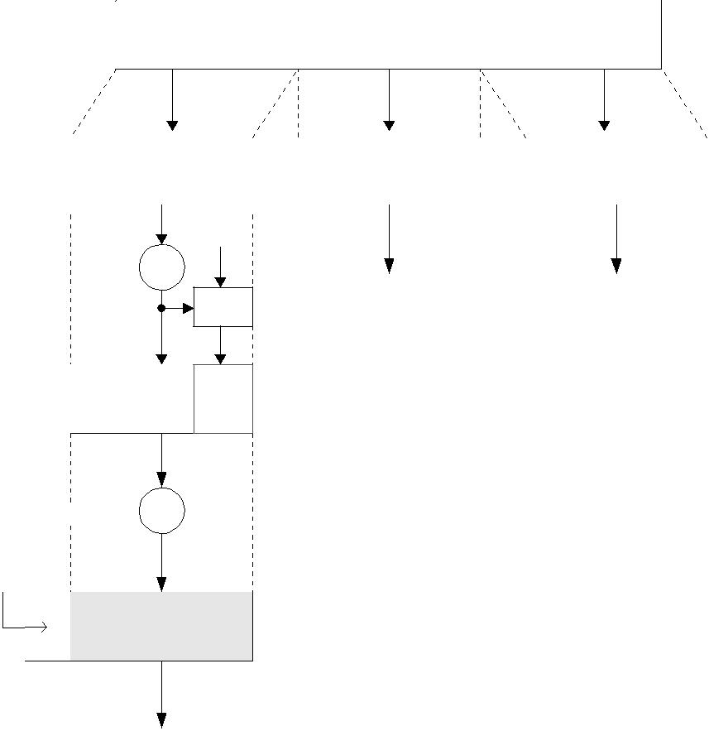

Application data

|  |  |  |  |  |
| --- | --- | --- | --- | --- |
| Fragment |  | Fragment |  | Fragment |
|  |  |  |  |  |

K

Compress C

H()

K : Shared sceret key

H() : Hash function (MD5 or SHA-1)

Compressed

MAC

data

Encrypt EK

SSL record header

Encrypted data

Transmit to TCP

**Figure 8.2** The overall operation of the SSL Record Protocol.

* *Compression and decompression*: All records are compressed using the compressionalgorithm defined in the current session state. The compression algorithm translates an SSLPlaintext structure into an SSLCompressed structure. Compression must be lossless and may not increase the current length by more than 1024 bytes. If the decom-pression function encounters an SSLCompressed.fragment that would decompress

to a length in excess of 214 = 16 348 bytes, it should issue a fatal decompression-failure alert.

Compression is essentially useful when encryption is applied. If both compres-sion and encryption are required, compression should be applied before encryption. The compression processing should ensure that an SSLPlaintext structure is identical after being compressed and decompressed. Compression is optionally applied in the SSL Record Protocol, but, if applied, it must be done before encryption and MAC computation.

* *MAC* : The MAC is computed before encryption. The computation of an MAC over thecompressed data is illustrated in Figure 8.3. Using a shared secret key, the calculation

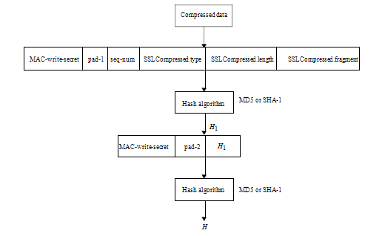

**Figure 8.3** Computation of MAC over the compressed data.

is defined as follows:

*H*1=hash(MAC-write-secret||pad-1||seq-num||SSLCompressed.type||

SSLCompressed.length || SSLCompressed.fragment)

*H* =hash(MAC-write-secret||pad-2||*H*1 *)*

where

Shared secret key Cryptographic hash algorithm; either MD5 or SHA-1

The byte 0x36 (0011 0110) repeated 48 times (384 bits) for MD5 and

40 times (320 bits) for SHA-1

The byte 0x5C (0101 1100) repeated 48 times for MD5 and

40 times for SHA-1

The sequence number for this message The higher-level protocol used to process this fragment

SSLCompressed.length: The length of the compressed fragment

|  |  |
| --- | --- |
| SSLCompressed.fragment: | The compressed fragment (the plaintext |
| ||: | fragment if not compressed) |
| concatenation symbol |

The compressed message plus the MAC are encrypted using symmetric encryption. The block ciphers being used as encryption algorithms are:

DES(56), Triple DES(168), IDEA(128),

RC5(variable) and Fortezza(80)

where the number inside the brackets indicates the key size. Fortezza is a PCMCIA card that provides both encryption and digital signing.

For block encryption, padding is added after the MAC prior to encryption. The total size of the data (plaintext plus MAC plus padding) to be encrypted must be a multiple of the cipher’s block length. Padding is added to force the length of the plaintext to be a multiple of the block cipher’s block length. Padding is formed by appending a single ‘1’ bit to the end of the message and then ‘0’ bits are added, as many as needed. The last 64 bits of the total size of padded data are reserved for the original message length.

For stream encryption, the compressed message plus the MAC are encrypted. Since the MAC is computed before encryption takes place, it is encrypted along with the compressed plaintext.

* *Append SSL record header* : The final processing of the SSL Record Protocol is toappend an SSL record header. The composed fields consist of:

– *Content type (8 bits)*: This field is the higher-layer protocol used to process the enclosed fragment.

– *Major version (8 bits)*: This field indicates the major version of SSL in use. For SSLv3, the value is 3.

– *Minor version (8 bits)*: This field indicates the minor version of SSL in use. For SSLv3, the value is 0.

– *Compressed length (16 bits)*: This field indicates the length in bytes of the plain-

text fragment or compressed fragment if compression is required. The maximum value is 214 + 2048.

Figure 8.4 illustrates the SSL Record Protocol format.

The SSL-specific protocols consist of the Change Cipher Spec Protocol, the Alert Protocol and the Handshake Protocol, as shown in Figure 8.1. The contents of these three protocols are presented in what follows.

**8.1.3** **SSL Change Cipher Spec Protocol**

The Change Cipher Spec Protocol is the simplest of the three SSL-specific protocols. This protocol consists of a single message, which is compressed and encrypted under the current CipherSpec. The message consists of a single byte of value 1. The change cipher spec message is sent by both the client and server to notify the receiving party

|  |  |  |  |  |  |  |  |  |  |  |
| --- | --- | --- | --- | --- | --- | --- | --- | --- | --- | --- |
|  | | | | | | | | |  | |
| Content | |  | Major | Minor |  | Compressed |  |  | | |
| type | |  | version | version |  | length |  |  | | |
|  | |  |  |  |  |  |  |  |  | |
|  | |  | Plaintext or compressed text | | |  |  |  |  | |
|  | |  |  |  |  |  |  | To be | | |
|  | |  |  |  |  |  |  | encrypted | | |
|  | |  | | | |  |  |  |  | |
|  | | MAC(0, 16 byte(MD5), 20 byte(SHA-1)) | | | |  |  |  |  | |
|  | |  |  |  |  |  |  |  |  | |
|  | |  |  |  |  |  |  |  |  | |



**Figure** SSL Record Protocol format.

that subsequent records will be protected under the just-negotiated CipherSpec and keys. Reception of this message causes the pending state to be copied into the current state, which updates the cipher suite to be used on this connection. The client sends a change cipher spec message following handshake key exchange and certificate verify messages (if any), and the server sends one after successfully processing the key exchange message it received from the client.

**SSL Alert Protocol**

One of the content types supported by the SSL Record Layer is the alert type. Alert messages convey the severity of the message and a description of the alert. Alert messages consist of 2 bytes. The first byte takes the value warning or fatal to convey the seriousness of the message. If the level is fatal, SSL immediately terminates the connection. In this case, other connections on the same session may continue, but the session identifiers must be invalidated, preventing the failed session from being used to establish new connections. The second byte contains a code that indicates the specific alert. As with other applications that use SSL, alert messages are compressed and encrypted, as specified by the current connection state.

A specification of SSL-related alerts that are always fatal is listed in the following:

* *unexpected-message*: An inappropriate message was received. This alert is alwaysfatal.
* *bad-record-mac*: This alert is returned if a record is received with an incorrect MAC.This message is always fatal.
* *decompression-failure*: The decompression function received improper input (i.e. datathat would expand to a length that is greater than the maximum allowable length). This message is always fatal.
* *no-certificate*: This alert message may be sent in response to a certificate request ifno appropriate certificate is available.
* *bad-certificate*: A received certificate was corrupt, i.e. contained a signature that didnot verify correctly.
* *unsupported certificate*: The type of the received certificate is not supported.
* *certificate-revoked* : A certificate has been revoked by its signer.
* *certificate-expired* : A certificate has expired or is not currently valid.
* *certificate-unknown*: This means some other unspecified issue arose in processing thecertificate, rendering it unacceptable.
* *illegal-parameter* : A field in the handshake was out of range or inconsistent withother fields. This is always fatal.
* *close-notify* : This message notifies the recipient that the sender will not send any moremessages on this connection. The session becomes unresumable if any connection is terminated without proper close-notify messages with level equal to warning. Each party is required to send a close-notify alert before closing the write side of the connection. Either party may initiate a close-notify alert. Any data received after a closure alert is ignored.

**SSL Handshake Protocol**

The SSL Handshake Protocol being operated on top of the SSL Record Layer is the most important part of SSL.

This protocol provides three services for SSL connections between the server and client.

The Handshake Protocol allows the client/server to agree on a protocol version, to authenticate each other by forming an MAC, and to negotiate an encryption algorithm and cryptographic keys for protecting data sent in an SSL record before the application protocol transmits or receives its first byte of data.

The Handshake Protocol consists of a series of messages exchanged by the client and server.

Figure 8.5 shows the exchange of handshake messages needed to establish a logical connection between client and server. The contents and significance of each message are presented in detail in the following sections.

*Phase 1: Hello Messages for Logical Connection*

The client sends a client hello message to which the server must respond with a server hello message, or else a fatal error will occur and the connection will fail. The client hello and server hello are used to establish security enhancement capabilities between client and server. The client hello and server hello establish the following attributes: protocol version, random values (ClientHello.random and ServerHello.random), session ID, cipher suite and compression method.

**Hello messages**

The hello phase messages are used to exchange security enhancement capabilities between client and server.

• *Hello request* : This message is sent by the server at any time, but may be ignoredby the client if the Handshake Protocol is already underway. A client who receives a hello request while in a handshake negotiation state should simply ignore the message.

* *Client hello*: The exchange is initiated by the client. A client sends a client hellomessage using the session ID of the session to be resumed. The server then checks its session cache for a match. If a match is found, the server will send a server hello message with the same session ID value. The client sends a client hello message with the following parameters:

– *Client version*: This is the version of the SSL protocol in which the client wishes to communicate during this session. This should be the most recent (highest-valued) version supported by the client. The value of this version will be 3.0.

– *Random*: This is a client-generated random structure with 28 bytes generated by

a secure random number generator.

– *Session ID* : This is the identity of a session when the client wishes to use this con-nection. A nonzero value indicates that the client wishes to update the parameters of an existing connection or create a new connection in this session. A zero value indicates that the client wishes to establish a new connection in a new session.

– *Cipher suites*: This is a list of the cryptographic options supported by the client, with the client’s first preference first. The single cipher suite is an element of a list selected by the server from the list in ClientHello.cipher suites. For a resumed session, this field is the value from the state of the session being resumed.

– *Compression method* : This is a list of the compression methods supported by the client, sorted by client preference. If the session ID field is not empty, it must include the compression method from that session.

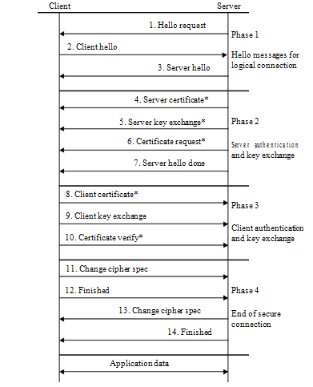

Asterisks (*) are optional or situation-dependent messages that are not always sent

**Figure 8.5** SSL Handshake Protocol.

* *Server hello*: The server will send the server hello message in response to a client hellomessage when it has found an acceptable set of algorithms. If it is unable to find such a match, it will respond with a handshake failure alert. The structure of this message consists of: server version, random, session ID, cipher suite and compression method.

– *Server version*: This field will contain the lower-valued version suggested by the client in the client hello and the highest-valued version supported by the server. The value of this version is 3.0.

– *Random*: This structure is generated by the server and must be different from ClientHello.random.

– *Session ID* : This field represents the identity of the session corresponding to this connection. If the ClientHello.session id is non-empty, the server will look in its session cache for a match. If a match is found and the server is willing to establish the new connection using the specified session state, the server will respond with the same value as was supplied by the client. This indicates a resumed session and dictates that the parties must proceed directly to the finished messages.

– *Cipher suite*: This is the single cipher suite selected by the server from the list in ClientHello.cipher suites. For a resumed session, this field is the value from the state of the session being resumed.

– *Compression method* : This is the single compression algorithm selected by the server from the list in ClientHello.compression methods. For a resumed sessions, this field is the value from the resumed session state.

*Phase 2: Server Authentication and Key Exchange*

|  |  |
| --- | --- |
| Following the hello messages, the server begins this phase by sending its certificate if it needs to be authenticated. Additionally, a server key exchange message may be sent if it is required. If the server is authenticated, it may request a certificate from the client, if that is appropriate to the cipher suite selected. Then the server will send the server hello done message, indicating that the hello message phase of the handshake is complete. The server will then wait for a client response. If the server has sent a certificate request message, the client must send the certificate message. |  |

* *Server certificate*: If the server is to be authenticated, it must send a certificate imme-diately following the server hello message. The certificate type must be appropriate for the selected cipher suite’s key exchange algorithm, and is generally an X.509 v3 certificate. It must contain a key which matches the key exchange method. The signing algorithm for the certificate must be the same as the algorithm for the certificate key.
* *Server key exchange message*: The server key exchange message is sent by the serveronly when it is required. This message is not used if the server certificate contains Diffie – Hellman parameters, or RSA key exchange is to be used for a signature-only RSA.

– params: the server’s key exchange parameters.

– signed-params: for non-anonymous key exchange, a hash of the corresponding params value, with the signature appropriate to that hash applied.

As usual, a signature is created by taking the hash of the message and encrypting it with the sender’s public key. Hence, the hash is defined as:

md5-hash : MD5(ClientHello.random||ServerHello.random||serverParams) sha-hash : SHA(ClientHello.random||ServerHello.random||serverParams) enum {anonymous, rsa, dsa} SignatureAlgorithm;

For a DSS signature, the hash is performed using the SHA-1 algorithm. In the case of an RSA signature, both an MD5 and an SHA-1 hash are calculated, and the con-catenation of the two hashes is encrypted with the server’s public key.

* *Certificate request message*: A non-anonymous server can optionally request a certifi-cate from the client, if appropriate for the selected cipher suite. This message includes two parameters, certificate type and certificate authorities. Its structure is as follows:

enum{

rsa_sign(1), des_sign(2), rsa_fixed_dh(3), dss_fixed_dh(4),

rsa_ephemeral_dh(5), dss_ephemeral_dh(6), fortezza_dms(20), (255)

} ClientCertificateType;

opaque DistinguishedName<1..216-1>; struct {

ClientCertificateType certificate_types<1..28-1>; DistinguishedName certificate_authorities<3..216-1>

} CertificateRequest;

– certificate types: This field is a list of the types of certificates requested, sorted in order of the server’s preference.

– certificate authorities: This is a list of the distinguished names of acceptable cer-tificate authorities. These distinguished names may specify a desired distinguished name for a root CA or for a subordinate CA; thus, this message can be used to describe both known roots and a desired authorization space.

Note that DistinguishedName is derived from X.509 and that it is a fatal handshake failure alert for an anonymous server to request client identification.

• *Server hello done message*: This message is sent by the server to indicate the endof the server hello and associated messages. After sending this message, the server will wait for a client response. This message means that server has finished sending messages to support the key exchange, and the client can proceed with its phase of the key exchange. Upon receipt of the server hello done message, the client should verify that the server provided a valid certificate if required and check that the server hello parameters are acceptable. If all is satisfactory, the client sends one or more messages back to the server.

*Phase 3: Client Authentication and Key Exchange*

If the server has sent a certificate request message, the client must send the certificate message. The client key exchange message is then sent, and the content of that message will depend on the public key algorithm selected between the client hello and the server hello. If the client has sent a certificate with signing ability, a digitally signed certificate verify message is sent to explicitly verify the certificate.

* *Client certificate message*: This is the first message the client can send after receiv-ing a server hello done message. This message is sent only when the server requests a certificate. If no suitable certificate is available, the client should send a certifi-cate message containing no certificates. If client authentication is required by the server for the handshake to continue, it may respond with a fatal handshake failure alert. The same message type and structure will be used for the client’s response to a certificate request message. Note that a client may send no certificates if it does not have an appropriate certificate to send in response to the server’s authentica-tion request. The client’s Diffie – Hellman certificates must match the server-specified Diffie-Hellman parameters.
* *Client key exchange message*: This message is always sent by the client. It will imme-diately follow the client certificate message, if it is sent. Otherwise it will be the first message sent by the client after it receives the server hello done message. With this message, the premaster secret is set, either through direct transmission of the RSA-encrypted secret, or by transmission of Diffie – Hellman parameters which will allow each side to agree upon the same premaster secret. When the key exchange method is DH – RSA or DH – DSS, client certification has been requested, and the client was able to respond with a certificate which contained a Diffie – Hellman public key whose parameters matched those specified by the server in its certificate; this message will not contain any data.
* *Certificate verify message*: This message is used to provide explicit verification of aclient certificate. The message is only sent following any client certificate that has signing capability (i.e. all certificates except those containing fixed Diffie – Hellman parameters). When sent, it will immediately follow the client key exchange message. This message signs a hash code based on the preceding messages, and its structure is defined as follows:

struct{

Signature signature; } CertificateVerify;

CertificateVerify.signature.md5_hash MD5(master_secret||pad2||MD5(handshake-message||

master_secret||pad1)) Certificate.signature.sha_hash

SHA(master_secret||pad2||SHA(handshake-message|| master_secret||pad1))

where pad1 and pad2 are the values defined earlier for the MAC, handshake-messages refer to all Handshake Protocol messages sent or received starting at client-hello but not including this message, and master secret is the calculated secret. If the user’s private key is DSS, then it is used to encrypt the SHA-1 hash. If the user’s private key is RSA, it is used to encrypt the concatenation of the MD5 and SHA-1 hashes.

*Phase 4: End of Secure Connection*

At this point, a change cipher spec message is sent by the client, and the client copies the pending CipherSpec into the current CipherSpec. The client then immediately sends the finished message under the new algorithms, keys and secrets. In response, the server will send its own change cipher spec message, transfer the pending CipherSpec to the current one, and then send its finished message under the new CipherSpec. At this point, the handshake is complete and the client and server may begin to exchange application layer data (see Figure 8.5).

* *Change cipher spec messages*: The client sends a change cipher spec message andcopies the pending CipherSpec in the current CipherSpec. This message is immediately sent after the certificate verify message that is used to provide explicit verification of a client certificate. It is essential that a change cipher spec message is received between the other handshake messages and the finished message. It is a fatal error if a change cipher spec message is not preceded by a finished message at the appropriate point in the handshake.
* *Finished message*: This is always sent immediately after a change cipher spec messageto verify that the key exchange and authentication processes were successful. The content of the finished message is the concatenation of two hash values:

MD5(master_secret||pad2||MD5(handshake_messages||Sender||

master_secret||pad1))

SHA(master_secret||pad2||SHA(handshake_messages||Sender||

master_secret||pad1))

where ‘Sender’ is a code that identifies that the sender is the client and ‘hand-shake messages’ is code that identifies the data from all handshake messages up to but not including this message.

The finished message is first protected with just-negotiated algorithms, keys and secrets. Recipients of finished messages must verify that the contents are correct. Once a side has sent its finished message and received and validated the finished message from its peer, it may begin to send and receive application data over the connection. Application data treated as *transparent data* is carried by the Record Layer and is fragmented, compressed and encrypted based on the current connection state.

**Cryptographic Computations**

The key exchange, authentication, encryption and MAC algorithms are determined by the cipher suite selected by the server and revealed in the server hello message. The compression algorithm is negotiated in the hello messages, and the random values are exchanged in the hello messages. The creation of a shared master secret by means of the key exchange and the generation of cryptographic parameters from the master secrete are of interest to study as two further items.

**Computing the Master Secret**

For all key exchange methods, the same algorithm is used to convert the premaster secret into the master secret. In order to create the master secret, a premaster secret is first exchanged between two parties and then the master secret is calculated from it. The master secret is always exactly 48 bytes (384 bits) shared between the client and server. But the length of the premaster secret is not fixed and will vary depending on the key exchange method.

There are two ways for the exchange of the premaster secret:

* *RSA*: When RSA is used for server authentication and key exchange, a 48-byte pre-master secret is generated by the client, encrypted with the server’s public key and sent to the server. The server decrypts the ciphertext (of the premaster secret) using its private key to recover the premaseter secret. Both parties then convert the premaster secret into the master secret as specified below.
* *Diffie –Hellman*: A conventional Diffie – Hellman computation is performed. Bothclient and server generate a Diffie-Hellman common key. This negotiated key is used as the premaster secret and is converted into the master secret, as specified below.

The client and server then compute the master secret as follows:

master_secret = MD5(pre_master_secret||SHA(‘A’|| pre_master_secret||ClientHello.random||

ServerHello.random))|| MD5(pre_master_secret||SHA(‘BB’|| pre_master_secret||ClientHello.random||

ServerHello.random))|| MD5(pre_master_secret||SHA(‘CCC’|| pre_master_secret||ClientHello.random||

ServerHello.random))

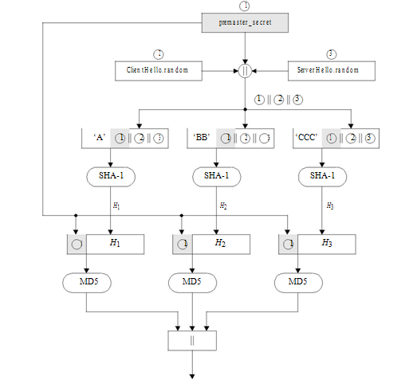

**Figure** Computation of the master secret.

where ClientHello.random and ServerHello.random are the two nonce values exchanged in the initial hello messages.

The generation of the master secret from the premaster secret is shown in Figure 8.6.

**Converting the Master Secret into Cryptographic Parameters**

CipherSpec specifies the bulk data encryption algorithm and a hash algorithm used for MAC computation, and defines cryptographic attributes such as the hash size.

To generate the key material, the following is computed:

292 INTERNET SECURITY

key_block = MD5(master_secret||SHA(‘A’||master_secret|| ServerHello.random||ClientHello.random))||

MD5(master_secret||SHA(‘BB’||master_secret||

ServerHello.random||ClientHello.random))||

MD5(master_secret||SHA(‘CCC’||master_secret|| ServerHello.random||ClientHello.random))||*. . .*

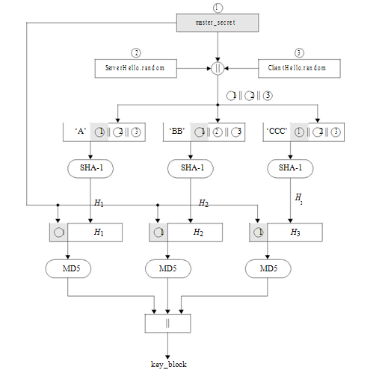

**Figure 8.7** Generation of key block.

until enough output has been generated. Note that the generation of the key block from the master secret uses the same format for generation of the master secret from the premaster secret. Figure 8.7 illustrates the steps for generation of the key block from the master secret.

**TLS Protocol**

The TLSv1 protocol itself is based on the SSLv3 protocol specification as published by Netscape. Many of the algorithm-dependent data structures and rules are very close so that the differences between TLSv1 and SSLv3 are not dramatic. The current work on TLS is aimed at producing an initial version as an Internet standard. It is recommended that readers examine the comparative studies between the TLSv1 of RFC 2246 and SSLv3 of Netscape. In this section, we will not repeat every detailed step of identical protocol contents, but only highlight the differences.

**HMAC Algorithm**

A Keyed-hashing Message Authentication Code (HMAC) is a secure digest of some data protected by a secret. Forging the HMAC is infeasible without knowledge of the MAC secret. HMAC can be used with a variety of different hash algorithms, namely MD5 and SHA-1, denoting these as HMAC MD5(secret, data) and HMAC SHA-1(secret, data).

There are two differences between the SSLv3 and TLSMAC schemes. TLS makes use of the HMAC algorithm defined in RFC 2104. HMAC was fully discussed in Chapters 4 and 7 and defined as:

HMAC = *H* [*(K* ⊕ opad*)*||*H* [*(K* ⊕ ipad*)*||*M*]]

where

ipad = 00110110*(*0x36*)* repeated 64 times (512 bits) opad = 01011100*(*0x5c*)* repeated 64 times (512 bits)

*H* =one-way hash function for TLS (either MD5 or SHA-1) *M* =message input to HMAC

*K* =padded secret key equal to the block length of the hash code(512 bits for MD5 and SHA-1)

The following explains the HMAC equation:

1. Append zeros to the end of *K* to create a *b*-byte string (i.e. if *K* = 160 bits in length and *b* = 512 bits, then *K* will be appended with 352 zero bits or 44 zero bytes 0x00).
2. XOR (bitwise exclusive-OR) *K* with ipad to produce the *b*-bit block computed in step 1.
3. Append *M* to the *b*-byte string resulting from step 2.
4. Apply *H* to the stream generated in step 3.
5. XOR (bitwise exclusive-OR) *K* with opad to produce the *b*-byte string computed in step 1.
6. Append the hash result *H* from step 4 to the *b*-byte string resulting from step 5.
7. Apply *H* to the stream generated in step 6 and output the result.

Figure 8.8 illustrates the overall operation of HMAC – MD5 or HMAC – SHA-1.

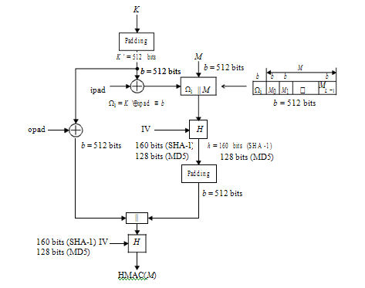

**Figure 8.8** Overall operation of HMAC computation using either MD5 or SHA-1 (message lengthcomputation based on *_*i ||*M*).

***Example 8.1*** HMAC – SHA-1 computation using RFC method:

Data : 0x 7104f218 a3192e65 1cf7025d 8011bf79 4a19

Key : 0x 31fa7062 c45113e3 2679fd13 53b71264

|  |  |  |  |  |  |
| --- | --- | --- | --- | --- | --- |
| – | A | B | C | D | E |
|  |  |  |  |  |  |
| IV | 67452301 | efcdab89 | 98badcfe | 10325476 | c3d2e1f0 |
| *H* [*(K* ⊕ipad*)*||*M*] | 8efeef30 | f64b360f | 77fd8236 | 273f0784 | 613bbd4b |
| *H* [*(K* ⊕opad*)*||*H* [*(K* ⊕ | 31db10b8 | ed346850 | d0f0b7dd | 50fd71f4 | 2dacd24c |
| ipad*)*||*M*]] |  |  |  |  |  |

HMAC – SHA-1 = 0x 31 db10b8 ed346850 d0f0b7dd 50fd71f4 2dacd24c

The alternative operation for computation of either HMAC – MD5 or HMAC – SHA-1 is described in the following:

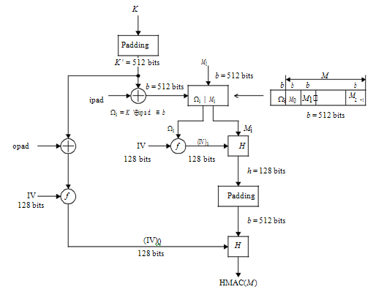

**Figure 8.9** Alternative operation of HMAC computation using MD5 (message length computationis based on *M* only).

1. Append zeros to *K* to create a *b*-bit string *K*_, where *b* = 512 bits.
2. XOR *K*_ (padding with zero) with ipad to produce the *b*-bit block.
3. Apply the compression function f(IV, *K*_⊕ ipad) to produce (IV)*i* = 128 bits.
4. Compute the hash code *h* with (IV)*i* and *Mi* .
5. Raise the hash value computed from step 4 to a *b*-bit string.
6. XOR *K*_ (padded with zeros) with opad to produce the *b*-bit block.
7. Apply the compression function f(IV, *K*_⊕ opad) to produce (IV)o = 128 bits.
8. Compute the HMAC with (IV)o and the raised hash value resulting from step 5.

Figure 8.9 illustrates the overall operation of HMAC – MD5.

***Example 8.2*** HMAC-MD5 computation using alternative method:Data : 0x 2143f501 f014a713 c1059e23 7123fd68

Key : 0x 31fa7062 c45113e3 2679fd13 53b71264

296 INTERNET SECURITY

|  |  |  |  |  |
| --- | --- | --- | --- | --- |
| – | A | B | C | D |
|  |  |  |  |  |
| IV | 67452301 | efcdab89 | 98badcfe | 10325476 |
| f[(*K* ⊕ ipad*), I V* ] = *(I V )*i | 13fbaf34 | 034879ab | 35e73505 | 526a8d28 |
| *H* [*M, (I V )*i] | 90c6d9b0 | 0f281bc8 | 94d04b33 | 7f0f4265 |
| f[*(K* ⊕ opad*), I V* ] = *(I V )*o | 5f8647d7 | fa8e9afa | bffa4989 | 3cd471d1 |
| *H* [*H* [*M, (I V )*i]*, (I V )*o] | 2c47cd5b | 68830268 | 7d255059 | 45c7bef0 |

HMAC – MD5 = 0*x* 2c47cd5b 68830268 7d255059 45c7bef0

For TLS, the MAC computation encompasses the fields indicated in the following expression:

HMAC_hash(MAC_write_secret, seq_num||TLScompressed.type|| TLSCompressed.version||TLSCompressed.length|| TLSCompressed.fragment)

Note that the MAC calculation includes all of the fields covered by the SSLv3 com-putation, plus the field TLSCompressed.version, which is the version of the protocol being employed.

**Pseudo-random Function**

TLS utilizes a pseudo-random function (PRF) to expand secrets into blocks of data for the purposes of key generation or validation. The PRF takes relatively small values such as a secret, a seed and an identifying label as input and generates an output of arbitrary longer blocks of data.

The data expansion function, P hash(secret, data), uses a single hash function to expand a secret and seed into an arbitrary quantity of output. The data expansion function is defined as follows:

P_hash(secret, seed) = HMAC_hash (secret, A(1)||seed) || HMAC_hash (secret, A(2)||seed) || HMAC_hash (secret, A(3)||seed) ||*. . .*

where A() is defined as:

A(0) = seed

A(i) = HMAC hash(secret, A(i-1)) and || indicates concatenation*.*

Applying A(i), i = 0*,* 1*,* 2*, . . . ,* to P hash, the resulting sketch can be depicted as shown in Figure 8.10. As you can see, P hash is iterated as many times as necessary to pro-duce the required quantity of data. Thus the data expansion function makes use of the HMAC algorithm with either MD5 or SHA-1 as the underlying hash function. As an example, consider SHA-1 whose value is 20 bytes (160 bits). If P SHA-1 is used to cre-ate 64 bytes (512 bits) of data, it will have to be iterated four times up to A(4), creating

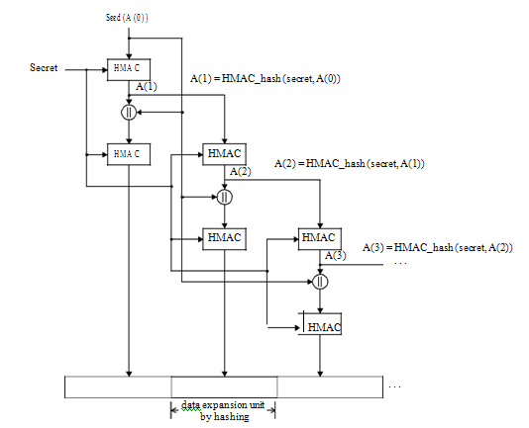

**Figure 8.10** TLS data expansion mechanism using P hash(secret,seed).

20 × 4 = 80 bytes (640 bits) of output data. Hence, the last 16 bytes (128 bits) of the final iteration A(4) must be discarded, leaving (80 − 16) = 64 bytes of output data. On the other hand, MD5 produces 16 bytes (128 bits). In order to generate an 80-byte output, P MD5 should exactly be iterated through A(5), while P SHA-1 will only iterate through A(4) as described above. In fact, alignment to a shared 64-byte output will be required to discard the last 16 bytes from both P SHA-1 and P MD5.

TLS’s PRF is created by splitting the secret into two halves (S1 and S2) and using one half to generate data with P MD5 and the other half to generate data with P SHA-1. These two results are then XORed to produce the output. S1 is taken from the first half of the secret and S2 from the second half. Their length is respectively created by rounding up the length of the overall secret divided by 2. Thus, if the original secret is an *odd* number of bytes long, the last bytes of S1 will be the same as the first byte of S2:

L S = length in bytes of secret L S1 = L *S*2 = ceil*(*L *S/*2*)*

The PRF is then defined as the result of mixing the two pseudo-random streams by XORing them together. The PRF is defined as:

PRF*(*secret, label, seed*)* = P MD5*(*S1, label||seed*)* ⊕ P SHA − 1*(*S2, label||seed*)*

The label is an ASCII string. Figure 8.11 illustrates the PRF generation scheme to expand secrets into blocks of data.

***Example*** Refer to Figure 8.11. Suppose the following parameters are given:

seed = 0x 80 af 12 5c 7e 36 f3 21

label = rocky mountains = 0x 72 6f 63 6b 79 20 6d 6f 75 6e 74 61 69 6e 73 secret = 0x 35 79 af 12 c4

Then

label||seed = 0x 72 6f 63 6b 79 20 6d 6f 75 6e 74 61 69 6e 73 80 af 12 5c 7e 36 f3 21

= A*(*0*)*

S1 = 0x 35 79 af for P MD5*,* S2 = 0x af 12 c4 for P SHA − 1

*Data expansion by P MD5* :

A(1) = HMAC MD5(S1, A(0))

= d0 de 36 53 79 78 04 a0 21 b8 6f f8 29 60 d5 f7

seed

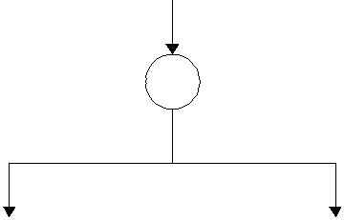

label     

|  |  |  |  |  |  |  |  |  |  |
| --- | --- | --- | --- | --- | --- | --- | --- | --- | --- |
| S1 |  |  | P_MD5 |  | P_SHA-1 |  |  | S2 |  |
|  |  |  |  |
|  |  |  |  |  |  |  |  |  |  |

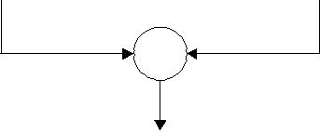



PRF(secret, label, seed)

S1: First half of the secret

S2: Second half of the secret

P_MD5: Data expansion function to expand a secret

S1 and (seed| | secret) using MD5

P_SHA-1: Data expansion function to expand a secret

S2 and (seed| | secret) using SHA-1

**Figure** A pseudo-random function (PRF) generation scheme.

HMAC MD5(S1, A(1)||A(0))

* 32 fd b3 70 eb 36 11 70 a4 3b 50 a9 fb ea 2a ec A(2) = HMAC MD5(S1, A(1))
* 8c ce 5b 50 02 af 75 91 e7 20 cd 86 d9 3e 67 9d HMAC MD5(S1, A(2)||A(0))
* 1f a8 4c af 5d e1 20 01 ea b0 38 6a a5 76 f9 8e A(3) = HMAC MD5(S1, A(2))
* 45 48 5d 00 4e 64 07 45 eb 2c 18 60 7c e6 fa 1f HMAC MD5(S1, A(3)|| A(0))
* f0 23 29 d9 5e 89 4b 70 cc 45 f8 aa 1f 58 8e 55 A(4) = HMAC MD5(S1, A(3))
* 87 39 c6 d3 7a b f8 e3 29 79 3a ae 63 24 6a ff HMAC MD5(S1, A(4)|| A(0))
* 2e 0c 27 26 d0 b4 78 85 09 a2 69 1c 1b 1b d7 8d A(5) = HMAC MD5(S1, A(4))
* 3a 2c aa d8 b3 ec 2e 5d 40 1c 39 bd 3e 48 1a d9 HMAC MD5(S1, A(5)|| A(0))
* 92 f2 63 5d 88 3a dd bf 8d ec e1 cf 0c 5c 8f 4c where S1 = 0x 35 79 af = first half of the secret, and A(0) = label||seed

Thus, P MD5 equals:

|  |  |  |  |  |  |  |  |  |  |  |  |  |  |  |  |  |
| --- | --- | --- | --- | --- | --- | --- | --- | --- | --- | --- | --- | --- | --- | --- | --- | --- |
| 32 | fd | b3 | 70 | eb | 36 | 11 | 70 | a4 | 3b | 50 | a9 | fb | ea | 2a | ec |  |
| 1f | a8 | 4c | af | 5d | e1 | 20 | 01 | ea | b0 | 38 | 6a | a5 | 76 | f9 | 8e |  |
| f0 | 23 | 29 | d9 | 5e | 89 | 4b | 70 | cc | 45 | f8 | aa | 1f | 58 | 8e | 55 |  |
| 2e | 0c | 27 | 26 | d0 | b4 | 78 | 85 | 09 | a2 | 69 | 1c | 1b | 1b | d7 | 8d |  |
| 92 | f2 | 63 | 5d | 88 | 3a | dd | bf | 8d | ec | e1 | cf | 0c | 5c | 8f | 4c | (80 bytes) |

*Data expansion by P SHA-1* :

A(1) = HMAC SHA1(S2, A(0))

* aa ea 46 1b a6 ad 43 34 51 f8 c6 ef 70 dd f4 60 ca b9 40 2f HMAC SHA1(S2, A(1)|| A(0))
* d0 8a d5 07 e0 b8 30 78 70 d9 c8 bb dd ba f5 a3 d0 77 49 e8 A(2) = HMAC SHA1(S2, A(1))
* 33 fd 23 41 01 ce 06 f8 c0 2b b3 e6 54 21 1c f4 6c 88 ab da

HMAC SHA1(S2, A(2)|| A(0))

* 64 b5 cc 3f 79 31 5b 5d e6 e4 4f eb 98 a8 bf 3f 97 13 38 e1 A(3) = HMAC SHA1(S2, A(2))
* 86 1f a3 a5 37 58 41 71 f1 9f a5 f3 48 2e 5d 84 7c a8 b6 52 HMAC SHA1(S2, A(3)|| A(0))
* 03 26 11 02 ce 69 74 4a 21 f4 76 55 13 af 77 80 2d fb 2f 36 A(4) = HMAC SHA1(S2, A(3))
* 9c 4d 01 3a 8c 48 54 42 68 07 4d f1 f0 a9 78 c3 6f ab d8 b4 HMAC SHA1(S2, A(4)|| A(0))
* 48 56 04 b5 b4 5f 9b d8 c7 2f 28 f6 9e 1d 8a c4 72 9a b9 32 where S2 = 0x af 12 c4 = second half of the secret, and

A(0) = label||seed

Thus, P SHA1 equals:

|  |  |  |  |  |  |  |  |  |  |  |  |  |  |  |  |  |
| --- | --- | --- | --- | --- | --- | --- | --- | --- | --- | --- | --- | --- | --- | --- | --- | --- |
| d0 | 8a | d5 | 07 | e0 | b8 | 30 | 78 | 70 | d9 | c8 | bb | dd | ba | f5 | a3 |  |
| d0 | 77 | 49 | e8 | 64 | b5 | cc | 3f | 79 | 31 | 5b | 5d | e6 | e4 | 4f | eb |  |
| 98 | a8 | bf | 3f | 97 | 13 | 38 | e1 | 03 | 26 | 11 | 02 | ce | 69 | 74 | 4a |  |
| 21 | f4 | 76 | 55 | 13 | af | 77 | 80 | 2d | fb | 2f | 36 | 48 | 56 | 04 | b5 |  |
| b4 | 5f | 9b | d8 | c7 | 2f | 28 | f6 | 9e | 1d | 8a | c4 | 72 | 9a | b9 | 32 | (80 bytes) |

Finally, P MD5 ⊕ P SHA − 1 equals:

|  |  |  |  |  |  |  |  |  |  |  |  |  |  |  |  |  |
| --- | --- | --- | --- | --- | --- | --- | --- | --- | --- | --- | --- | --- | --- | --- | --- | --- |
| e2 | 77 | 66 | 77 | 0b | 8e | 21 | 08 | d4 | e2 | 98 | 12 | 26 | 50 | df | 4f |  |
| cf | df | 05 | 47 | 39 | 54 | ec | 3e | 93 | 81 | 63 | 37 | 43 | 92 | b6 | 65 |  |
| 68 | 8b | 96 | e6 | c9 | 9a | 73 | 91 | cf | 63 | e9 | a8 | d1 | 31 | fa | 1f |  |
| 0f | f8 | 51 | 73 | c3 | 1b | 0f | 05 | 24 | 59 | 46 | 2a | 53 | 4d | d3 | 38 |  |
| 26 | ad | f8 | 85 | 4f | 15 | f5 | 49 | 13 | f1 | 6b | 0b | 7e | c6 | 36 | 7e | (80 bytes) |

**Error Alerts**

The Alert Protocol is **classified** into the **closure alert** and the **error alert.**

One of the content types supported by the TLS Record Layer is the alert type.

Alert messages convey the severity of the message and a description of the alert. Alert messages with a fatal level result in the immediate termination of the connection.

The client and the server must share knowledge that the connection is ending in order to avoid a truncation attack.

Either party may initiate a close by sending a close notify alert. This message notifies the recipient that the sender will not send any more messages on this connection.

|  |  |
| --- | --- |
| Error handling in the TLS Handshake Protocol is very simple.  When an error is detected, the detecting party sends a message to the other party. Upon transmission or receipt of a fatal alert message, both parties immediately close the connection. |  |

TLS supports all of the error alerts defined in SSLv3 with the exception of additional alert codes defined in TLS. The additional error alerts are described in the following:

* **decryption failed**: A TLS ciphertext is decrypted in an invalid way: either it was not an even multiple of the block length or its padding values, when checked, were incorrect. This message is always fatal.
* **record overflow**: A TLS record was received with a ciphertext whose length exceeds 214 + 2048 bytes, or the ciphertext decrypted to a TLS compressed record with more

than 214 + 1024 bytes. This message is always fatal.

* **unknown ca**: A valid certificate chain or partial chain was received, but the certificate was not accepted because the CA certificate could not be located or could not be matched with a known, trusted CA. This message is always fatal.
* **access denied**: A valid certificate was received, but when access control was applied, the sender decided not to proceed with the negotiation. This message is always fatal.
* **decode error**: A message could not be decoded because a field was out of its specified range or the length of the message was incorrect. This message was incorrect. It is always fatal.
* **decrypt error**: A handshake cryptographic operation failed, including being unable to verify a signature, decrypt a key exchange or validate a finished message.
* **export restriction:** A negotiation not in compliance with export restrictions was detected; for example, attempting to transfer a 1024-bit ephemeral RSA key for the RSA EXPORT handshake method. This message is always fatal.
* **protocol version**: The protocol version the client has attempted to negotiate is recog-nised but not supported due to the fact that old protocol versions might be avoided for security reasons. This message is always fatal.
* **insufficient security**: Returned instead of hanshake failure when a negotiation has failed specifically because the server requires ciphers more secure than those supported by the client. This message is always fatal.
* **internal error**: An internal error unrelated to the peer or the correctness of the protocol, such as a memory allocation failure, makes it impossible to continue. This message is always fatal.
* **user canceled**: This handshake is being cancelled for some reason unrelated to a pro-tocol failure. If the user cancels an operation after the handshake is complete, just closing the connection by sending a close notify is more appropriate. This alert should be followed by a close notify. This message is generally a warning.
* **no renegotiation**: This is sent by the client in response to a hello request or by the server in response to a client hello after initial handshaking. Either of these messages would normally lead to renegotiation, but this alert indicates that the sender is not able to renegotiate. This message is always a warning.

For all errors where an alert level is not explicitly specified, the sending party may determine at its discretion whether this is a fatal error or not; if an alert with a level of warning is received, the receiving party may decide at its discretion whether to treat this as a fatal error or not. However, all messages which are transmitted with a level of fatal must be treated as fatal messag

**Certificate Verify Message**

Recall that the hash computations for SSLv3 are included with the master secret, the handshake message and pads. In the TLS certificate verify message, the MD5 and SHA-1 hashes are calculated only over handshake messages as shown below:

CertificateVerify.signature.md5_hash MD5(handshake_message)

CertificateVerify.signature.sha_hash SHA(handshake_message)

Here handshake messages refer to all handshake messages sent or received starting at client hello up to, but not including, this message, including the type and length fields of the handshake messages.

**Finished Message**

A finished message is always sent immediately after a change cipher spec message to verify that the key exchange and authentication processes were successful. It is essential that a change cipher spec message be received between the other handshake messages and the finished message. As with the finished message in SSLv3, the finished message in TLS is a hash based on the shared master secret, the previous handshake messages, and a label that identifies client and server. However, the TLS computation for verify data is somewhat different from that of the SSL calculation as shown below:

PRF(master_secret, finished_label, MD5(handshake_message)|| SHA-1(handshake_message))

where

* The finished label indicates either the string ‘client finished’ sent by the client or the string ‘server finished’ sent by the server, respectively.
* The handshake message includes all handshake messages starting at client hello up to, but not including, this finished message. This is only visible at the handshake layer and does not include record layer headers. In fact, this is the concatenation of all the handshake structures exchanged thus far. This may be different from handshake messages for SSL because it would include the certificate verify message. Also, the handshake message for the finished message sent by the client will be different from that for the finished message sent by the server.

Note that change cipher spec messages, alters and any other record types are not handshake messages and are not included in the hash computation

**Cryptographic Computations (for TLS)**

In order to begin connection protection, the TLS Record Protocol requires specifica-tion of a suite of algorithms, a master secret, and the client and server random values.

The authentication, encryption and MAC algorithms are determined by the cipher suite selected by the server and revealed in the server hello message. The compression algo-rithm is negotiated in the hello messages, and the random values are exchanged in the hello messages.

All that remains is to compute the master secret and the key block. The premaster secret for TLS is calculated in the same way as in SSLv3. The presmater secret should be deleted from memory once the master secret has been computed. As in SSLv3, the master secret in TLS in calculated as a hash function of the premaster secret and two hello random numbers.

The TLS master secret computation is different from that of SSLv3 and is defined as follows:

master_secret = PRF(premaster_secret, ‘‘master secret’’, ClientHello.random||ServerHello.random)

The master secret is always exactly 48 bytes (384 bits) in length. The length of the premaster secret will vary depending on key exchange method:

* *RSA*: When RSA is used for server authentication and key exchange, a 48-byte pre-master secret is generated by the client, encrypted with the server’s public key, and sent to the server. The server uses its private key to decrypt the premaster secret. Both parties then convert the premaster secret into the master secret, as specified above.
* *Diffie –Hellman*: A conventional Diffie – Hellman computation is performed. The nego-tiated key Z is used as the premaster secret, and is converted into the master secret, as specified above.

The computation of the key block parameters (MAC secret keys, session encryption keys and IVs) is defined as follows:

key_block = PRF(master_secret, ‘‘key expansion’’, SecurityParameters.server_random||

SecurityParameters.client_random)

until enough output has been generated. As with SSLv3, key block is a function of the master secret and the client and server random numbers, but for TLS the actual algorithm is different.

On leaving this chapter, it is recommended that readers search for and find any other small differences between SSL and TLS.